SPORTS AND GAMES

8
UNIT

PRONOUNCIATION

/e/ | /æ/
ready | black
1. Âm /e/
1.1. “a” được phát âm là /e/
Examples | Transcription | Meaning
many | /meni/ | nhiều
anyone | /eniwʌn / | bất kỳ ai
1.2. “e” phát âm là /e/ khi nó nằm trong những từ một âm tiết có tận cùng là một hay nhiều phụ âm (trừ “r”)- ead, air, are
Examples | Transcription | Meaning
get | /get/ | có, trở nên
bread | /bred/ | bánh mì
1.3. “ea” được phát âm là /e/ trong một số trường hợp
Examples | Transcription | Meaning
heavy | /hevi/ | nặng
breakfast | /'brekfǝst/ | bữa sáng
2. Âm /æ/
“a” được phát âm là /æ/ trong các trường hợp:
2.1. Trong những từ có một âm tiết mà tận cùng bằng một hay nhiều phụ âm
Examples | Transcription | Meaning
hat | /hæt/ | cái mũ
sad | /sæd/ | buồn
2.2. Khi ở trong một âm tiết được nhấn mạnh của một chữ có nhiều âm tiết và đứng trước hai phụ âm
Examples | Transcription | Meaning
candle | /ˈkændl/ | cây nến
captain | /ˈkæptɪn/ | đại úy, thuyền trưởng

Task 1. Put the words into the correct columns.

heavy | men | latter | hence | bell
happy | pleasure | snack | extend
pants | gel | bag | cheque | draught
narrow  shell | have | dead | hell | black
hand | drag | ten | bag | bread

/æ/
……………………………………………………………….....................................................................................
……………………………………………………………….....................................................................................
……………………………………………………………………………….
…………………………………………………
…………………………………………………
………………………………………………….

/e/
………………………………………………………………...........................................................
………………………………………………………………...........................................................
…………………………………………………………………..
…………………………………………………
…………………………………………………
………………………………………………….

Task 2: Choose the word which has the underlined part pronounced differently from the others.

1. A. gate B. sensitive C. date D. fate
2. A. rain B. they C. bread D. lake
3. A. anyone B. many C. head D. safe
4. A. translation B. dead C. tender D. measure
5. A. obey B. leather C. train D. paint
6. A. hearken B. perhaps C. marvelous D. task
7. A. park B. March C. map D. shark
8. A. charge B. manner C. shall D. candle
9. A. bar B. hard C. thank D. start
10. A. can B. jam C. sand D. smart

8

SPORTS AND GAMES
UNIT

VOCABULARY

New words | Transcription | Meaning
achievement | /əˈtʃiːvmənt/ | thành tựu
aerobics | /eəˈrəʊbɪks/ | môn thể dục nhịp điệu
athlete | /ˈæθliːt/ | vận động viên
badminton | /ˈbædmɪntən/ | môn cầu lông
basketball | /ˈbɑːskɪtbɔːl/ | môn bóng rổ
bat | /bæt/ | gậy đánh bóng chày
blind man’s bluff | /blaɪnd mænz blʌf/ | trò bịt mắt bắt dê
boat | /bəʊt/ | con thuyền
boxing | /ˈbɒksɪŋ/ | môn đấm bốc
breaststroke | /ˈbreststrəʊk/ | bơi ếch
career | /kəˈrɪə(r)/ | nghề nghiệp, sự nghiệp
chess | /tʃes/ | cờ vua
chew | /tʃuː/ | nhai
congratulation | /kənɡrætʃuˈleɪʃn/ | chúc mừng
court | /kɔːt/ | sân (quần vợt)
cycling | /ˈsaɪklɪŋ/ | đạp xe đạp
elect | /ɪˈlekt/ | bầu chọn, bình chọn
equipment | /ɪˈkwɪpmənt/ | dụng cụ
exhausted | /ɪɡˈzɔːstɪd/ | mệt lả, kiệt sức
fantastic | /fænˈtæstɪk/ | tuyệt vời
fishing | /ˈfɪʃɪŋ/ | môn câu cá
fit | /ˈfɪt/ | khỏe mạnh, vừa vặn
football | /ˈfʊtbɔːl/ | môn bóng đá
football match | /ˈfʊtbɔːl mætʃ/ | trận đấu bóng đá
football player | /ˈfʊtbɔːl ˈpleɪər/ | cầu thủ bóng đá
goggles | /ˈɡɒɡlz/ | kính (bảo hộ)
gym | /dʒɪm/ | phòng tập thể dục
individual | /ɪndɪˈvɪdjuəl/ | có tính cá nhân
karate | /kəˈrɑːti/ | môn ka-ra-tê
last | /lɑːst/ | kéo dài
marathon | /ˈmærəθən/ | cuộc đua ma-ra-tông
marble | /ˈmɑːbl/ | viên bi
match | /mætʃ/ | trận đấu
Olympic games | /əʊˈlɪmpɪk geɪmz/ | thế vận hội Olympic
pedal | /ˈpedəl/ | bàn đạp (xe đạp)
playground | /ˈpleɪɡraʊnd/ | sân chơi
professional | /prəˈfeʃənəl/ | chuyên nghiệp
racket | /ˈrækɪt/ | vợt (chơi quần vợt)
referee | /refəˈriː/ | trọng tài
regard | /rɪˈɡɑːd/ | coi như, xem như
ring | /rɪŋ/ | vũ đài (thể thao)
running | /ˈrʌnɪŋ/ | môn chạy
sailing | /ˈseɪlɪŋ/ | môn chèo thuyền
skateboard | /ˈskeɪtbɔːd/ | ván trượt
skateboarding | /ˈskeɪtbɔːdɪŋ/ | môn trượt ván
ski | /skiː/ | ván trượt bang
skiing | /skiːɪŋ/ | môn trượt bang
skipping | /skɪpɪŋ/ | nhảy dây
sport shoes | /spɔːts ʃuː/ | giày thể thao
sports competition | /spɔːts kɒmpəˈtɪʃn/ | cuộc thi đấu thể thao
sporty | /ˈspɔːti/ | yêu thể thao
stadium | /ˈsteɪdiəm/ | sân vận động
swallow | /ˈswɒləʊ/ | nuốt
swimming | /ˈswɪmɪŋ/ | môn bơi lội
table tennis | /ˈteɪbl ˈtenɪs/ | môn bóng bàn
tennis | /ˈtenɪs/ | môn quần vợt
tug of war | /tʌg əv ˈwɔːr/ | trò kéo co
volleyball | /ˈvɒlibɔːl/ | môn bóng chuyền
weather forecast | /ˈweðə ˈfɔːkɑːst/ | dự báo thời tiết

Task 1. Look at the pictures and complete the blanks.

boxing | karate | table tennis | aerobics
tennis | cycling | skateboarding | skiing

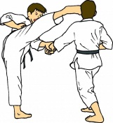 | 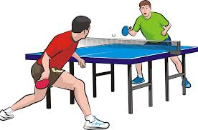 | 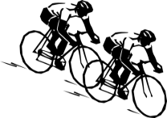 | 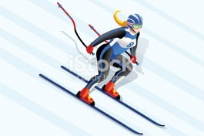
1. ______________ | 2. ______________ | 3. ______________ | 4. ______________
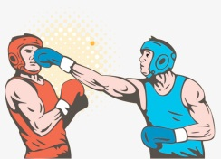 | 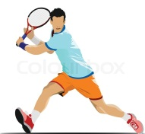 | 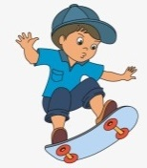 | 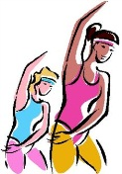
5. ______________ | 6. ______________ | 7. ______________ | 8. ______________

Task 2. Use the sports or games in the list to fill in the boxes.

badminton | karate | cycling | yoga | skateboarding | soccer
aerobics | football | gymnastics | jogging | swimming | basketball
hiking | golf | judo | boxing | skiing | tennis
DO
………………………………………………………………
………………………………………………………………
…………………………………………………
…………………………………………………
…………………………………………………
………………………………………………….
GO
………………………………………………………………
………………………………………………………………
…………………………………………………
…………………………………………………
…………………………………………………
………………………………………………….
PLAY
………………………………………………………………
………………………………………………………………
…………………………………………………
…………………………………………………
…………………………………………………
………………………………………………….

Task 3. Write the name of sport/ game under the correct picture.

 | 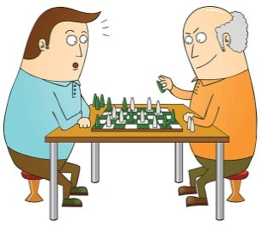 | 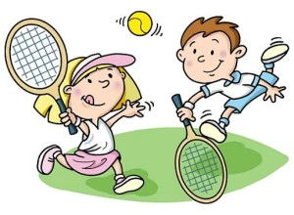 | 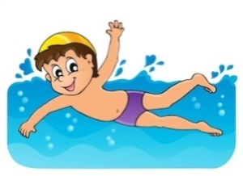
1. ______________ | 2. ______________ | 3. ______________ | 4. ______________
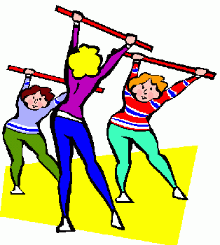 | 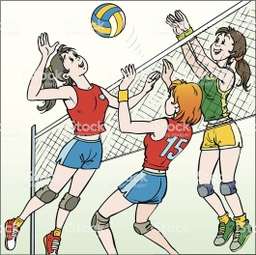 | 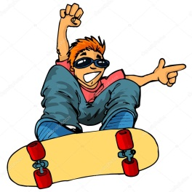 | 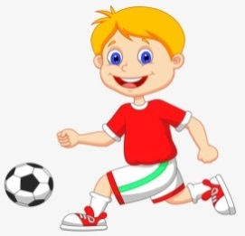
5. ______________ | 6. ______________ | 7. ______________ | 8.______________

Task 4. Read the definitions and complete the blanks with given words

goggles court breaststroke stadium volleyball
achievement skipping rope boxing tug of war referee

1. A sport in which two people fight each other with their hands, while wearing very large thick gloves. _____________

2. A game in which two teams of six players use their hands to hit a large ball backwards and forwards over a high net while trying not to let the ball touch the ground on their own side. _____________

3. A pair of glasses that fit closely to the face to protect the eyes from wind, dust, water, etc. _____________
4. A thing that somebody has done successfully, especially using their own effort and skill. _____________
5. A style of swimming that you do on your front, moving your arms and legs away from your body and then back towards it in a circle. _____________
6. A place where games such as tennis are played. _____________
7. A type of sport in which two teams show their strength by pulling against each other at the opposite ends of a rope, and each team tries to pull the other over a line on the ground. _____________
8. A piece of rope, usually with a handle at each end, that you hold, turn over your head and then jump over, for fun or to keep fit. _____________
9. A large sports ground surrounded by rows of seats and usually other buildings. _____________
10. A person who is in charge of a sports game and who makes certain that the rules are followed. _____________

8

+*
SPORTS AND GAMES
UNIT

GRAMMAR

I. Past simple
a. Form
 | Normal Verb | To be
(+) | S + Ved | You, we, they + were  I, he, she, it + was
(-) | S + didn’t + V-inf | You, we, they + weren’t  I, he, she, it + wasn’t
(?) | Did + S + V-inf? | Were + you, we, they?  Was + I, he, she, it?
b. How to change infinitive verbs into past form
Động từ ở thì quá khứ được chia làm 2 loại: có quy tắc và bất quy tắc.
❖ Đối với động từ có quy tắc, khi chuyển sang dạng quá khứ, ta thêm đuôi “ed”.
help helped want wanted
❖ Nếu động từ kết thúc bằng nguyên âm + y, ta thêm đuôi “ed" như bình thường.
play played stay stayed
❖ Nếu động từ kết thúc bằng phụ âm + y ta đổi y ied.
cry cried study studied
❖ Đối với động từ bất quy tắc: tra dạng quá khứ trong Bảng động từ bất quy tắc.
c. Use
Dùng để diễn tả hành động đã xảy ra và kết thúc hoàn toàn trong quá khứ. (Trong câu thường có các trạng ngữ chỉ thời gian)
Example
She worked for Thang Long Company last year. Now she is working for the BBC Company. (Năm ngoái cô ấy làm việc cho công ty Thăng Long. Năm nay cô ấy làm việc cho công ty BBC.)
d. Signals
- yesterday (hôm qua), at that moment (lúc đó), last night (tối hôm qua)
- last + week/ month/ year: tuần/ tháng/ năm vừa rồi
- Khoảng thời gian + ago (cách đây ...): two days ago (cách đây 2 ngày), three years ago (cách đây 3 năm)
- In + năm: in 2000 (năm 2000)
2. Imperatives
Câu mệnh lệnh dùng khi ta muốn yêu cầu ai đó làm việc hoặc đừng làm việc gì đó
Form
(+) V!
(-) Don’t + V!
Example
- Look at the board! (Hãy nhìn lên bảng)
- Don’t play with the dog! (Đừng đùa với con chó!)

Task 1. Give correct form of the verb:

- Change the verbs into simple past form.

No. | Present form | Past form | No. | Present form | Past form
1. | be | _______________ | 9. | read | _______________
2. | play | _______________ | 10. | listen | _______________
3. | go | _______________ | 11. | learn | _______________
4. | do | _______________ | 12. | drink | _______________
5. | bring | _______________ | 13. | work | _______________
6. | see | _______________ | 14. | forget | _______________
7. | find | ______________ | 15. | have | _______________
8. | give | _______________ | 16. | know | _______________

II. Complete the following sentences with the correct form of the verbs in brackets.
1. I (not be) very happy yesterday.
2. The people in the café (not be) ___ friendly when I was there yesterday.
3. I (leave) my school bag at school this morning.
4. It (be) a great film in 2001.
5. Our teacher (tell) us to be quiet yesterday.
6. I went to the shop but I (not have) any money.
7. Susan (not know) about the exam and she did very badly.
8. I (buy) a ticket for the football match yesterday.
III. Complete the funny story with the Past Simple of the verbs in brackets.
It (1.be) Sunday, the day of the big game. The players (2.arrive)____ early. They (3. be) excited. Everyone (4.want) to play. There (5.be) lots of people in the stadium. They (6. wave) and (7.cheer) when the players (8.walk) on to the ground.
The referee (9. call) the captains to the middle. The referee (10. ask) . "Where is the ball?" Nobody (11. answer) .
All the players (12.look) at the ground. There (13.be) no ball. The referee (14.cancel)_____ the game.

Task 2. Fill in the blank using the words in the box.

Turn left | Catch | Don’t be late! | Have | Open
Stop the car! | Come in | Don’twait | Don’t forget | Come
Pass | Help me! | Take | Don’t listen

1. Don’t wait for me. I’m not coming tonight.  2. ______an umbrella with you. It’s raining.  3. a rest. You look tired.  4. at the end of the street.  5. I can’t swim!  6. to take your passport.  7. ___________There’s a mouse in the road. | 8. ___________to my cocktail party, please.  9. your books at page 15.  10. the salt, please.  11. ___________to that record. It’s terrible.  12. __________The train leaves at 8 o’clock.  13. and have a glass of lemonade.  14. __________the first train in the morning.
Task 3. Choose the best answer to complete each of the following sentences.

1. I ________ a English course to improve all the skills.
A. not joined B. joined C. did joined D. join
2. We _______to our friend last night.
A. spoke B. speak C. speaked D. spoken
3. We ________ and__________ lunch at the cafeteria with them.
A. talked/have B. talked/ had C. talk/had D. talked/ have
4. __________you attend yoga class when I___________ at home?
A. Did/ stayed B. Didn’t/ didn’t stayed
C. Did/ didn’t stayed D. Did/ stayed
5. I __________his car to work while he was sleeping.
A. drive B. drove C. driving D. driven

6. The man ________________the door and ____________pieces of paper.
A. open/ thrown B. opened/ threw
C. opened/ thrown D. open/ throw
7. He ______ them into a room.
A. led B. lead C. leaded D. leads
8. He ___________off his hat and________ into the room.
A. take/went B. take/go C. taken/go D. took/ went
9. The meeting .___________5 minutes ago.
A. finished B. finish C. did not finish D. did finish
10. When _______ she _____________ the report?
A. do/ finish B. did/ finished C. did/finish D. didn’t/ finished
Task 4. Find the mistake in the four underlined parts A, B, C or D of each sentence.

1. Did your uncle took you to watch the football match last week?
A B C D
2. Last summer my parents buyed me a lot of different gifts.
A B C D
3. There was many people standing on the street.
A B C D
4. I ate noodles for dinner but I wasn’t eat anything for lunch.
A B C D
5. The food was delicious, but most things didn’t cheap.
A B C D
6. Albert Park is a relaxed and interesting place to spend the day.
A B C D
7. This is the most wonderful weather I have experience this week .
A B C D
8. He is going to take an umbrella but it is raining heavily outside.
A B C D
9. She is the most happy woman in the world .
A B C D
10. Skiing , skating and karate are my favourite games .
A B C D

8
SPORTS AND GAMES
UNIT

SPEAKING

Task 1. Match the questions and answer. Then practice.

- Do you like to watch sports on TV? |  | - Volleyball, I think.
- What sports are you best at? |  | - Three or four times.
- How much exercise do you get each week? |  | - Because it can help them be healthy.
- Did you do any exercise or play any sports yesterday? |  | - Yes, I like watching sports more than playing them.
- Do you prefer team sports or individual sports? |  | - I don’t like either of them. I’m not a sporty person.
- What is the most popular sport in the world? |  | - Football or soccer
- Which is better, basketball or volleyball? |  | - Swimming and Taekwondo.
- Why should people exercise? |  | - Yes, I played tennis with friends
Task 2. Answer the questions.

- …………………………….  ……………………………. |  | Last night I watched a basketball match on TV.
- ……………………………. |  | It was on The Thao HD Channel
- ……………………………. |  | I like basketball best.
- ……………………………. |  | I play basketball every weekend.
- …………………………….  ……………………………. |  | I often play it at the basketball court near my house
- ………………………………  ……………………………. |  | My favourite basketball player is LeBron James.

8
+*
SPORTS AND GAMES
UNIT

LISTENING

Task 1. Listen to a friend talking about his sports activities every week. On which day does he do the kinds of sports below? Put a tick into the correct column.

 | Basketball | Football | Swimming | Chess
Monday
Tuesday
Wednesday
Thursday
Friday
Saturday
Sunday

Task 2. Listen again. Decide if the following statements are true (T) or false (F)

1. He goes swimming at 6 o’clock on Monday.
2. He plays basketball between 7a.m. and 9 a.m. on Tuesday.
3. He can’t do any sports on Thursday.
4. On Friday morning, he join a chess club at his school.
5. His football team often loses the matches.

8

+*
SPORTS AND GAMES
UNIT

READING

Task 1. Read again and answer the questions.

My last Sports Day occurred on the 8th of September in 2016. On that day, the school was beautifully decorated with colorful flags. Parents were invited to watch their children participate in many events.
In the morning, our class was divided into four groups and they competed against one another. The children used balls, hoops, skipping-ropes and bags in the competition. The parents cheered them very much.
In the afternoon, we had more interesting events. The Upper Primary students competed in many sports such as hurdles, relay races, short distance races, high jump and long jump. Every participant tried their best to win as many trophies as possible for their team.
The prize-giving ceremony marked the end of the exciting day. The winners were cheered and carried on their classmates’ shoulders. Though we were very tired, we had enjoyed ourselves very much.

1. When did her last Sports Day take place?

2. What was the school decorated with?

3. Who were invited to watch her children participate in many events?

4. What did the children use in the competition?

5. What sports did the Upper Primary student compete in?

6. Why did the participants try their best?

Task 2. Complete the passage with the words from the box.

score without sport each play game positions boring

Basketball is a pretty cheap (1)___________ to play in terms of equipment. So long as you have shoes and clothes and a ball, you can play. You can play with 1 hoop or 2, but it is way more fun to have a full court to (2)___________ on and several friends to do it with. Of course, you can have knee braces, expensive shoes, and some fancy jerseys if you want, but you can play (3)___________ them if you want.
Basketball is a (4)___________ of 5-on-5. There are 5 different (5)___________: point guard, shooting guard, center, small forward, and power forward. Unlike some other sports, all players can (6)___________ points, and there is NO goalkeeper. There isn’t a (7)___________ position to play!
Basketball has 4 quarters. For pro games, quarters are 15 minutes. Teams switch directions of play after (8)___________ quarter.
Task 3. Choose the correct answers to complete the passage.

Physical activity is the (1) _______ obvious benefit of sports participation. Children often spend too much time watching television or (2) _______ video games. But sports practices and games provide an opportunity for exercise that can help keep kids in shape and (3) _______.
Sports participation can help children develop social skills that will benefit them (4)_______ their entire lives. They learn to interact not only with other children their age, (5) _______ also with older individuals in their coaches and sports officials. Kids learn leadership skills, team-building skills and communication skills that will help them in school, their future (6)_______ and personal relationships.
1. A. more B. much C. most D. least
2. A. doing B. playing C. paying D. watching
3. A. healthy B. wealthy C. happy D. funny
4. A. for B. on C. at D. throughout
5. A. and B. so C. but D. then
6. A. world B. career C. game D. shape

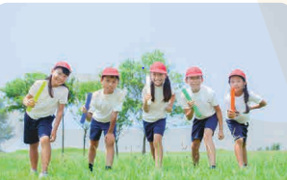

8

+*
SPORTS AND GAMES
UNIT

WRITING

Task 1. Put the words in the correct order:

1. which/ you/ do/ sports/ at/do/ school?
……………………………………………………………………………………
2.do/ when/ do/ you/ sport?
……………………………………………………………………………………
3. favourite/ are/ your/ who/ sports stars?
……………………………………………………………………………………
4.do/you/ go/ how often/ running?
……………………………………………………………………………………
5.team/ sports/ play/ you/ do?
……………………………………………………………………………………
6. what/ TV/ you/ do/ on/ sports/ watch?
……………………………………………………………………………………
7.football/ is/ what/ favourite/ your/ team?
……………………………………………………………………………………
8.swimming/ you/ do/ go/ how often?
……………………………………………………………………………………
Task 2. Write 6 sentences about football.

……………………………………………………………………………………………………………………………………
……………………………………………………………………………………………………………………………………
……………………………………………………………………………………………………………………………………
……………………………………………………………………………………………………………………………………
……………………………………………………………………………………………………………………………………
……………………………………………………………………………………………………………………………………
……………………………………………………………………………………………………………………………………
……………………………………………………………………………………………………………………………………
……………………………………………………………………………………………………………………………………
……………………………………………………………………………………………………………………………………

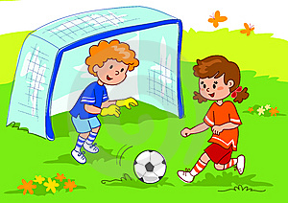

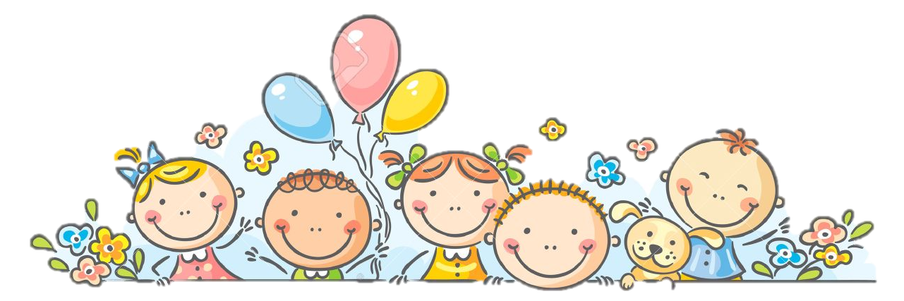

………

ĐÁP ÁN CHI TIẾT

+*
SPORTS AND GAMES
8
UNIT

PRONOUNCIATION

Task 1. Put the words into the correct columns.

/e/
men  gel  leather  ten  shell  pleasure  bell  extend | cheque  bread  sense  hell  heavy  hence  dead

/æ/
happy bag
pants narrow
black hand
latter drag
snack have

Task 2: Choose the word which has the underlined part pronounced differently from the others.

1. B 2. C 3. D 4. A 5. B
6. B 7. C 8. A 9. C 10. D

8

+*
SPORTS AND GAMES
UNIT

VOCABULARY

Task 1. Look at the pictures and complete the blanks.

1. karate 2. table tennis 3. cycling 4. skiing 5. boxing
6. aerobics 7. Skateboarding 8. marathon 9. tennis 10.volleyball

Task 2. Use the sports or games in the list to fill in the boxes.

go |  | play | soccer | do
 | skateboarding |  | football |  | yoga
 | skiing |  | basketball |  | gymnastics
 | hiking |  | golf |  | judo
 | swimming |  | volleyball |  | boxing
 | cycling |  | tennis |  | aerobics
 | jogging |  | football |  | karate
 |  |  | badminton

Task 3. Write the name of sport/ game under the correct picture.

1. boxing 2. chess 3. tennis 4. swimming
5. aerobics 6. volleyball 7. skateboarding 8. football
Task 4. Read the definitions and complete the blanks with given words

1. boxing 2. volleyball 3. goggles 4. achievement 5. breaststroke
6. court 7. tug of war 8. skipping rope 9. stadium 10. referee

8

SPORTS AND GAMES
UNIT

GRAMMAR

Task 1.

- Change the verbs into simple past form.

No. | Present form | Past form | No. | Present form | Past form
1. | be | _was/were_____ | 9. | read | ---read
2. | play | _______Played___ | 10. | listen | ___Listened ___
3. | go | _______went____ | 11. | learn | ____learnt ____
4. | do | _______did_____ | 12. | drink | ____drank______
5. | bring | ______brought___ | 13. | work | ___worked ____
6. | see | ______saw______ | 14. | forget | ______forgot___
7. | find | ______found____ | 15. | have | ______had_____
8. | give | ___gave________ | 16. | know | _____knew_____

II. Complete the following sentences with the correct form of the verbs in brackets.
1. wasn’t | 2. weren’t | 3. left | 4. was
5. told | 6. didn’t | 7. didn’t know | 8. bought
III. Complete the funny story with the Past Simple of the verbs in brackets.
1. was | 2. arrived | 3.were | 4. wanted | 5. were
6. waved | 7. cheered | 8. walked | 9. called | 10. asked
11. answered | 12. looked | 13. was | 14. cancelled
Task 2

Turn left | Catch | Don’t be late! | Have | Open
Stop the car! | Come in | Don’twait | Don’t forget | Come
Pass | Help me! | Take | Don’t listen

1. Don’t wait for me. I’m not coming tonight.  2. __Take____an umbrella with you. It’s raining.  3. Have a rest. You look tired.  4. Turn left at the end of the street.  5. Help me! I can’t swim!  6. __Don’t forget to take your passport.  7. ___Stop the car___________There’s a mouse in the road. | 8. ___Come________to my cocktail party, please.  9. __Open your books at page 15.  10. ___Pass the salt, please.  11. _Don’t listen__________to that record. It’s terrible.  12. _Don’t be late_________The train leaves at 8 o’clock.  13. ___Come in and have a glass of lemonade.  14. _____Catch_____the first train in the morning.
Task 3.

1.C | 6.B
2.B | 7.B
3.A | 8.A
4.B | 9.D
5.C | 10.A
Task 4.

1.B | 6.B
2.B | 7.C
3.A | 8.C
4.C | 9.B
5.D | 10.D

8

+*
SPORTS AND GAMES
UNIT

SPEAKING

Task 1. Match the questions and answer. Then practice.

- Do you like to watch sports on TV? | 1-d | - Volleyball, I think.
- What sports are you best at? | 2-a | - Three or four times.
- How much exercise do you get each week? | 3-b | - Because it can help them be healthy.
- Did you do any exercise or play any sports yesterday? | 4-h | - Yes, I like watching sports more than playing them.
- Do you prefer team sports or individual sports? | 5-e | - I don’t like either of them. I’m not a sporty person.
- What is the most popular sport in the world? | 6-f | - Football or soccer
- Which is better, basketball or volleyball? | 7-a | - Swimming and Taekwondo.
- Why should people exercise? | 8-c | - Yes, I played tennis with friends
Task 2. Answer the questions.

1. What did you do last night?
2.Which channel was it on?
3.What sport do you like best?/What is your favourite sport?
4.How often do you play basketball?
5.Where do you often play it?
6.Who is your favourite basketball player?

8

+*
SPORTS AND GAMES
UNIT

LISTENING

Task 1. Listen to a friend talking about his sports activities every week. On which day does he do the kinds of sports below? Put a tick into the correct column.

 | Basketball | Football | Swimming | Chess
Monday
Tuesday
Wednesday
Thursday
Friday
Saturday
Sunday

Task 2. Listen again. Decide if the following statements are true (T) or false (F)

1. F 2. T 3. F 4.T 5.F

Listening transcript:
I love sports. I spend much of my time doing different kinds of sports. Every Monday and Wednesday afternoon, at 5 o’clock, I go swimming with my closet friend. On Tuesday morning, I don’t have a class, so I play basketball from 7 am to 9 am. I can’t do any sports on Thursday because I have too many classes at school. Every Friday morning, I join a chess club at my school. Saturday and Sunday afternoon are for exciting football matches. I am in a strong team, and we often win the matches.

8

+*
SPORTS AND GAMES
UNIT
READING

Task 1. Read again and answer the questions.

- Her Sports Day occurred on the 8th of September in 2016
- the school was beautifully decorated with colorful flags
- Parents were invited to watch their children participate in many events.
- The children used balls, hoops, skipping-ropes and bags in the competition.
- The Upper Primary students competed in many sports such as hurdles, relay races, short distance races, high jump and long jump.

Task II. Complete the passage with the words from the box.
1. sport | 2. play | 3. without | 4. game
5. positions | 6. score | 7. boring | 8. each

Task III. Choose the correct answers to complete the passage.
1.C | 2.B | 3.A | 4.A | 5.C | 6.B

8

+*
SPORTS AND GAMES
UNIT

WRITING

Task 1. Reorder the words

1. Which sports do you do at school?
2. When do you do sports?
3. Who are your favourite sports stars?
4. How often do you go running?
5. Do you play team sports?
6. What sports do you watch on TV?
7. What is your favourite football team?
8. How often do you go swimming?

Task 2. Write about football.

……………………………………………………………………………………………………………………………………
……………………………………………………………………………………………………………………………………
……………………………………………………………………………………………………………………………………
……………………………………………………………………………………………………………………………………
……………………………………………………………………………………………………………………………………
……………………………………………………………………………………………………………………………………
……………………………………………………………………………………………………………………………………
……………………………………………………………………………………………………………………………………
……………………………………………………………………………………………………………………………………
……………………………………………………………………………………………………………………………………

