3
MY FRIENDS
UNIT

+*
PRONOUNCIATION

/b/ | /p/
back | pen
Task 1. Put the words into the correct columns.

biscuit parents ponytail bit blonde picture
band big brown picnic play bring
/p/
………………………………………………………………………………………
………………………………………………………………………………………
…………………………………………………
…………………………………………………
…………………………………………………
………………………………………………….
/b/
………………………………………………………………
………………………………………………………………
………………………………………………………………
…………………………………………………
…………………………………………………
………………………………………………….

Task 2. Circle the word that has the underlined part pronounced differently

1. A. best B. part C. pie D. pen
2. A. bow B. pie C. back D. baby
3. A. copy B. happy C. beast D. pull
4. A. bed B. job C. pass D .bull
5. A. ban B. pet C. peach D. pier
6. A.bat B. beer C. bye D. prize
7. A. pig B. chubby C. pin D. pole
8. A. better B. bobby C. birthday D. provide
9. A. pencil B. pocket C. boy D. postcard
10. A. about B. professional C. beautiful D. butterfly

MY FRIENDS
3
UNIT

VOCABULARY

New words | Transcription | Meaning
arm | /ɑːm/ | cánh tay
ear | /ɪər/ | tai
elbow | /ˈelbəʊ/ | khuỷu tay
eye | /aɪ/ | mắt
face | /feɪs/ | khuôn mặt
foot | /fʊt/ | bàn chân
fur | /fɜːr/ | lông
glasses | /glɑːsɪz/ | kính mắt
hand | /hænd/ | bàn tay
head | /hed/ | cái đầu
knee | /niː/ | đầu gối
leg | /leg/ | cẳng chân
mouth | /maʊθ/ | miệng
neck | /nek/ | cái cổ
nose | /nəʊz/ | cái mũi
tail | /teɪl/ | cái đuôi
tooth | /tuːθ/ | răng
cheek | /tʃiːk/ | má
finger | /fɪŋgər/ | ngón tay
shoulder | /ʃəʊldər/ | vai
talkative | /ˈtɔːkətɪv/ | nói nhiều, hay nói
clever | /ˈklevər/ | khéo léo
boring | /ˈbɔːriŋ/ | tẻ nhạt
creative | /kriˈeɪtɪv/ | sáng tạo
shy | /ʃaɪ/ | rụt rè, bẽn lẽn
kind | /kaɪnd/ | tốt bụng
confident | /ˈkɒnfɪdənt/ | tự tin
hard-working | /hɑːd-ˈwɜːkɪŋ/ | chăm chỉ
friendly | /frendli/ | thân thiện
funny | /ˈfʌni/ | hài hước
short | /ʃɔːt/ | thấp, lùn
long | /lɒŋ/ | dài
black | /blæd/ | màu đen
blonde | /blɒnd/ | màu vàng hoe
curly | /ˈkɜːli/ | quăn
straight | /streɪt/ | thẳng
chubby | /ˈtʃʌbi/ | mập mạp, mũm mĩm
choir | /kwaɪər/ | đội hợp xướng
firework competition | /ˈfaɪəwɜːk kɒmpəˈtɪʃən/ | cuộc thi pháo hoa
greyhound racing | /ˈgreɪhaʊnd ˈreɪsɪŋ/ | đua chó
field trip | /ˈfiːld trɪp/ | chuyến đi về vùng quê
temple | /ˈtempl/ | ngôi đền
volunteer | /vɒlənˈtɪər/ | tình nguyện viên
independent | /ɪndɪˈpendənt/ | độc lập
curious | /kjʊəriəs/ | tò mò
freedom-loving | /friːdəm-ˈlʌvɪŋ/ | yêu tự do
responsible | /rɪˈspɒntsəbl/ | chịu trách nhiệm
reliable | /rɪˈlaɪəbl/ | đáng tin cậy
sensitive | /ˈsentsɪtɪv/ | nhạy cảm

Task 1. Fill in each blank to find names of parts of the body.

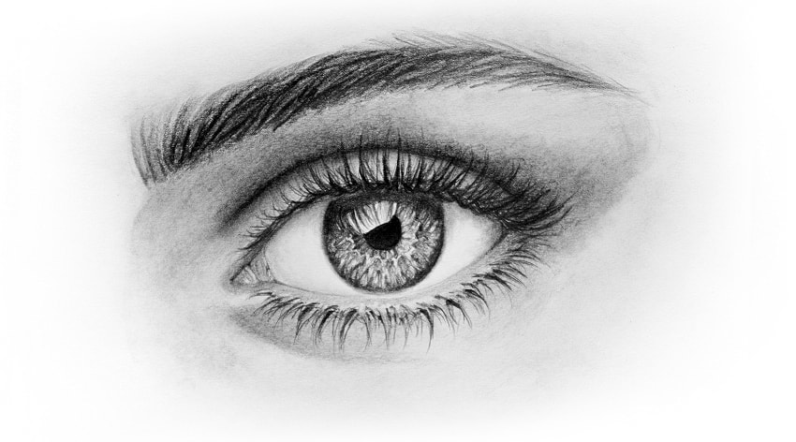  _y_ | 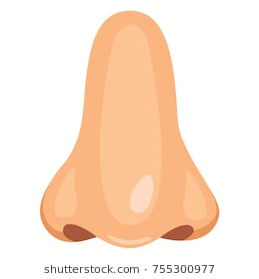  n_s_ | m_ _th | 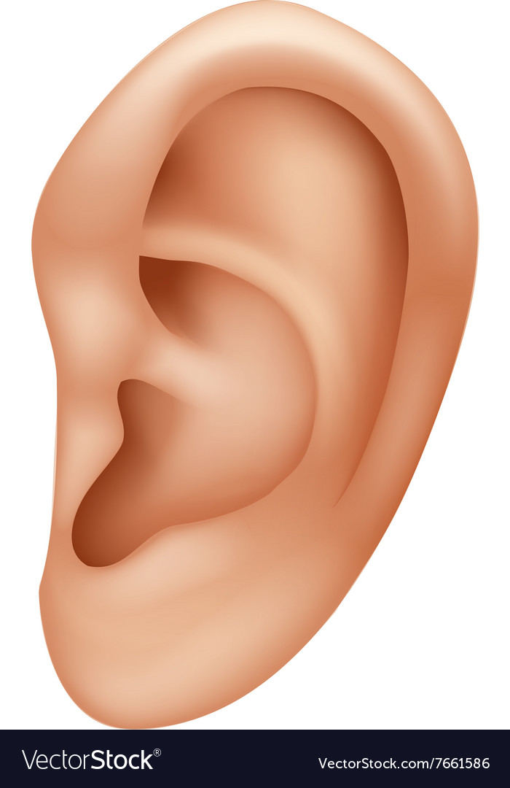  e_r | 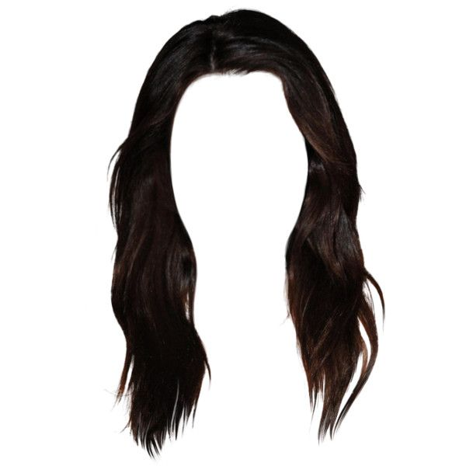  h_ _r
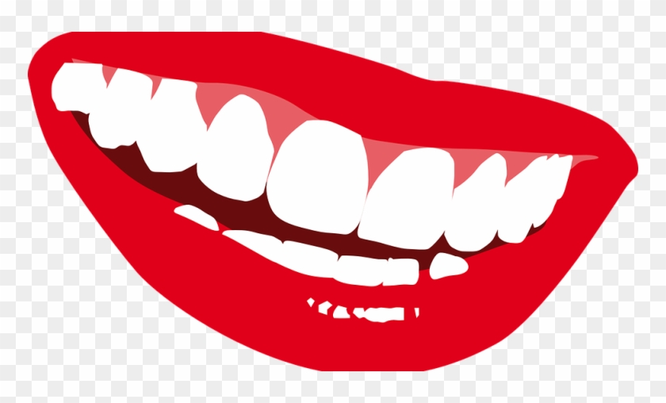  t_ _t_ | 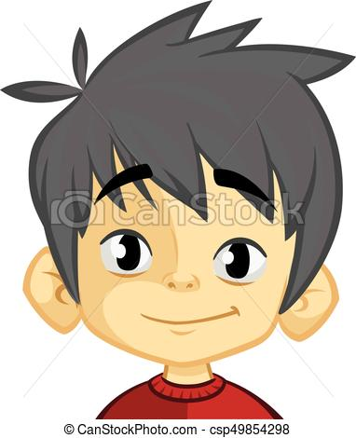  _ac_ | 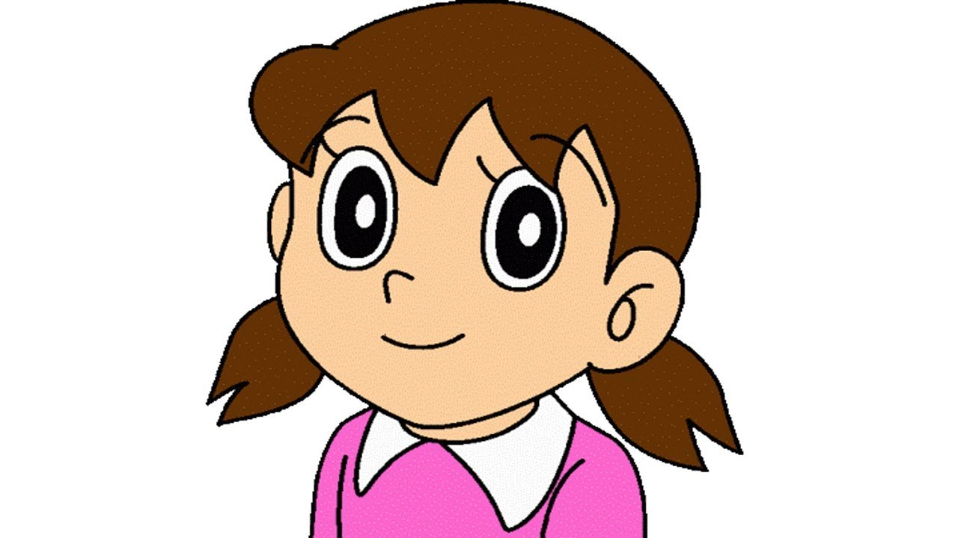  h_ _d | 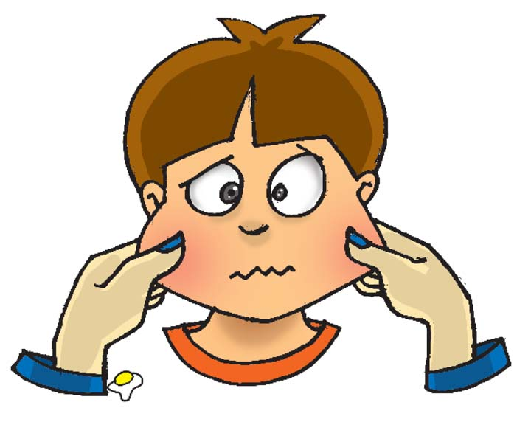  _h_e_s | 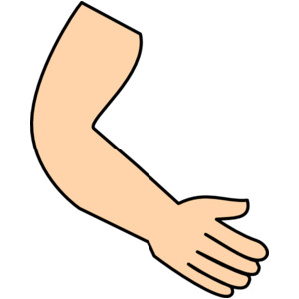  _r_
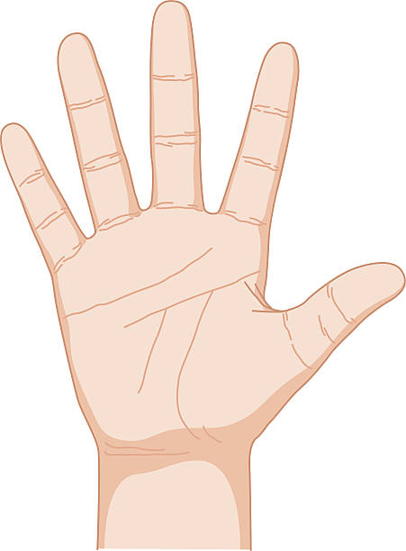  _a_d | 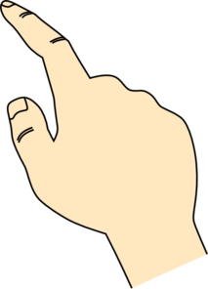  f_n_e | _lb_w | 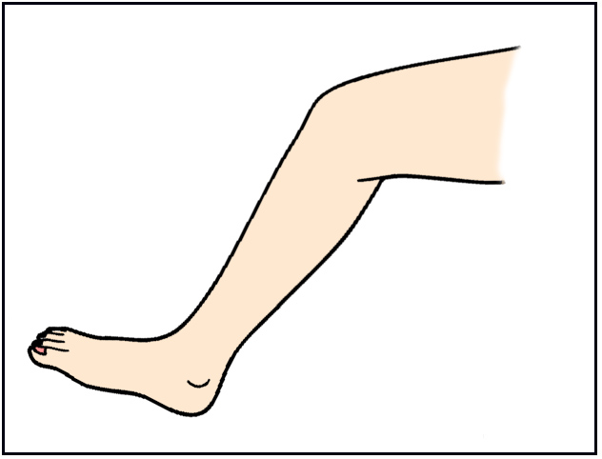  _e_ | 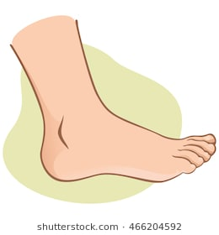  f_ _ t
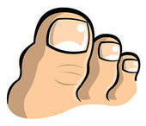  _o_s | 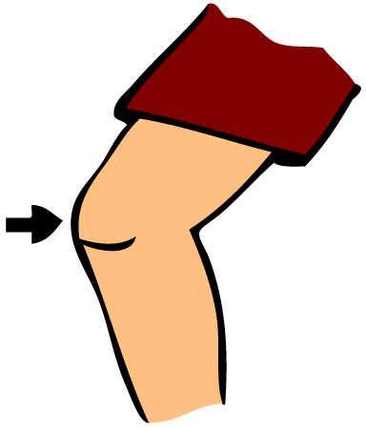  _n_e | 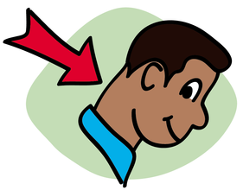  n_ _k | b_c_ | 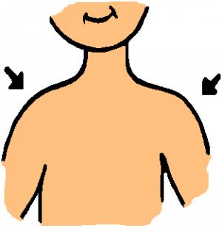  s_o_l_ _rs

Task 2. Choose a suitable adjective for each picture below

friendly | talkative | kind | boring | fun
confident | fat | shy | hard-working | creative

_________________ | 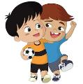  ________________ | 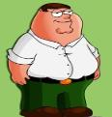  ________________ | ________________ | ________________
_________________ | 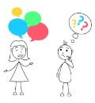  _________________ | ________________ | ________________ | 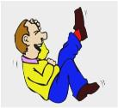  _________________
Task 3. Read and circle the right adjectives.

1. Donata is very friendly/ rude. She has a lot of friends.
2. Mona is very reliable/ creative. She always has new ideas.
3. Ann is a bit interesting/ boring. She never has anything interesting to say.
4. Jully is very funny/ shy. She likes telling jokes.
5. Anna is very serious/sensitive. She cries quickly whenever she watches a romance movie.
6. Lucy is very outgoing/ generous. She likes meeting and talking to people.
7. Joana is very hard-working/ lazy. She never helps with the housework.
8. Jane is very nervous/ impatient. She becomes annoyed if she has to wait for something or someone.
9. Mathew is very active/ helpful. He likes to play sport or do physical things.
10. Helen is a quiet/ curious person. She isn’t very talkative.
Task 4. Fill in each blank with the correct adjective from the box.

kind boring shy funny clever
friendly talkative creative confident hard-working
1. He’s a little bit . He likes to talk a lot.
2. She always has a smile with everyone.
3. Everyone is to me. They often help me when I need.
4. It is to sit on the plane with nothing to read.
5. She is very . She writes poetry and paints.
6. It’s a really film; everyone laughs a lot.
7. Children are often at school and he always gets good marks.
8. He is often of people they don’t know.
9. The teacher wants the students to feel about asking questions when they don’t understand.
10. I’m not very at Math. I often make mistakes in calculations.
Task 5. Read the definitions and complete the blanks with given words.

tooth foot shoulder eye neck
knee leg mouth cheek head
No. | Definitions | Word
1. | One of the long parts that connect the feet to the rest of the body | ..........................
2. | The part of the body between the head and the shoulders | ..........................
3. | Any of the hard white structures in the mouth used for biting and chewing food | ..........................
4. | Either side of the face below the eyes | ..........................
5. | Either of the two parts of the body between the top of each arm and the neck | ..........................
6. | The part of the body on top of the neck containing the eyes, nose, mouth and brain | ..........................
7. | The lowest part of the leg, below the ankle, on which a person or an animal stands | ..........................
8. | The joint between the top and bottom parts of the leg where it bends in the middle | ..........................
9. | Either of the two organs on the face that are used for seeing | ..........................
10. | The opening in the face used for speaking, eating, etc. | .....................

3
MY FRIENDS
UNIT

GRAMMAR

1. Description with be and have
a. Be
Câu khẳng định | I + am + adj  You, we, they + are + adj  He, she, it + is + adj
Câu phủ định | I + am not + adj  You, we, they + aren’t + adj  He, she, it + isn’t + adj
Câu nghi vấn | Am + I + adj?  Are + you, we, they + adj?  Is + he, she, it + is + adj?
b. Have
Câu khẳng định | I, you, we, they + have +...  He, she, it + has + ...
Câu phủ định | I, you, we, they + haven’t +...  He, she, it + hasn’t + ...
Câu nghi vấn | Have + I, you, we, they + ...?  Has + he, she, it +...?

Example
- He is hard-working. (Anh ấy chăm chỉ.)
- I am not creative. (Tôi không sáng tạo.)
- I have a round face. (Tôi có khuôn mặt tròn.)
- She has a pink notebook. (Chị ấy có quyển vở màu hồng.)
2. Present continuous (Thì hiện tại tiếp diễn)
a. Form
(+) | I + am + V-ing.  You, we, they + are + V-ing.  He, she, it + is + V-ing.
(-) | I am not + V-ing.  You, we, they + aren’t + V-ing.  He, she, it + isn’t + V-ing.
(?) | Am + I + V-ing?  Are + you, we, they + V-ing?  Is + he, she, it + V-ing?
b. Usage
- Thì hiện tại tiếp diễn diễn tả một hành động đang diễn ra tại thời điểm nói.
VD: My mother is cooking in the kitchen now. (Hiện tại mẹ tôi đang nấu ăntrong bếp.)
❖ Thì hiện tại tiếp diễn diễn tả một hành động hoặc sự việc đang diễn ra xung quanh thời điểm nói.
VD: Linda is quite busy these days. She’s doing the English project for her school. (Linda is in a restaurant with her friend now.)
(Linda dạo này rất bận. Cô ấy đang làm dự án tiếng Anh cho trường của cô ấy.) (Hiện tại Linda đang ngồi trong nhà hàng với bạn cô ấy.)
- Thì hiện tại tiếp diễn có thể diễn tả một hành động sắp xảy ra trong tương lai gần (điều này đã được lên kế hoạch).
VD: He is going to Paris. (Anh ấy định đi Paris.)
- Thì hiện tại tiếp diễn diễn tả một hành động thường xuyên xảy ra lặp đi lặp lại gây sự bực mình hay khó chịu cho người nói. Cách dùng này được dùng với trạng từ “always, continually”.
VD: Tony is careless. He is always losing his keys. (Tom thì bất cẩn.Anh lấy luôn làm mất chìa khoá.)
c. Signals
Các trạng từ hay gặp: now, at the present, at the moment, at this time(bây giờ, lúc này)
Các động từ: Look! (Nhìn kìa), Listen(Nghe này); Becareful!(Cẩn thận);Hurry up! (Nhanh lên)
d. How to add“ing” after verbs
- Thông thường nhất, ta thêm đuôi -ing vào sau các động từ.
readreading go going
- Khi động từ kết thúc bằng “e”, ta bỏ “e” trước khi thêm “ing”.
havehaving make making
❖ Khi động từ kết thúc bằng “ee”, ta thêm ing mà không bỏ “e”.
seeseeing agree agreeing
❖ Khi động từ kết thúc bằng “ie” ta đổi “ie”->“y” rồi thèm “ing”.
lielying die dying
❖ Khi âm tiết cuối của động từ mang trọng âm và có chứa 1 nguyên âm + 1 phụ âm, ta gấp đôi phụ âm cuối rồi thêm “ing”.
runrunning permit permitting
e. Note
Chúng ta không dùng thì hiện tại tiếp diễn với các động từ thuộc về nhận thức, tri giác hoặc sự sở hữu như: be, see, hear, understand, know, like, want, feel, smell, remember, forget,...Tasử dụng thì hiện tại đơn thay vì hiện tại tiếp diễn trong các trường hợp này.
Example
False: She is being happy.
Correct: She is happy.
Task 1.Verbs form:

I. Complete the sentences with forms of be or have.
1. She ____________ long blond hair.
2. He ____________ green eyes. They look so nice.
3. He ____________ short blond hair.
4. His eyes ____________ black and quite large.
5. Her eyes’ color ____________ green. It is brown.
6. She ____________ in good-shape. She is a little thin.
7. (she) ____________ straight black hair? - Yes.
8. My uncle ____________ medium-height. He is just a little taller than me.
9. What (John) ____________ on his nose? - Glasses. He is reading a book.
10. (Mai) ____________ short black hair or long brown hair?
11. His mouth is small and he ____________ green eyes.
12. George ____________ short hair like most of men. His hair is quite long and smooth.
13. Miranda’s parents have brown eyes, but she doesn’t. Her eyes ____________ blue.
14. Which is his complexion’s color? (it) ____________ tanned?
15. My grandfather ____________ a moustache. He has got a beard.
II. Read the text then give the correct form of verb.
It (0. be) is Sunday evening and my friends and I (1. be) __________ Jane’s birthday party. Jane (2. wear) ___________a beautiful long dress and (3. stand) _____ next to her boyfriend. Some guests (4. drink) ______wine or beer in the corner of the room. Some of her relatives (5. dance) ______ in the middle of the room. Most people (6.sit) __________on chairs, (7. enjoy) ________ foods and (8. chat) _______with one another. We often (9. go) ________ to our friends’ birthday parties. We always (10. dress) ________ well and (11. travel) _________by taxi. Parties never (12. make) ________us bored because we like.
III. Complete the text. Use the present simple.
My best friend
My best friend is Hannah. She (1. live) next door to me. We (2. go) to the same school but we are in different classes.
I (3. walk) to school but Hannah (4. go) by bike, because she always (5. get up) late. After school we (6. finish) _____ our homework first, then we (7. listen) to our favourite music. I (8. like) R&B, but Hannah (9.hate) it. She (10. think) it’s boring. She (11. love) rock music.

Task 2. Arrange the adjectives in the blanks in the correct order

1. He has (long/ grey/ a) beard.

2. They are (small/ beautiful/ red) flowers.

3. That car is (big/ a/ modern/ black).

4. She has (long/ blonde) hair.

5. My uncle lives in (modern/ big/ brick/ a) house.
……………………………………………………………………………….
Task 3. Choose the underlined word or phrase (marked A, B, C or D) that needs correcting

1. My sister is very seriously and hard-working in her study.
A B C D
2. Ride a bike at the weekend is my best friend's hobby.
A B C D
3. She is very cared, so she always helps her mother do the housework.
A B C D
4. My friend has a short brown hair and an oval face.
A B C D
5. Because Nga is very keen on the school's singing competition, she is taking part
A B C
on it tomorrow.
D
6. I have an important maths exam tomorrow afternoon, so I do a lot of maths
A B C exercises at home this evening.
D
7. We have a lot of assignments to do. Therefore, we are going to the cinema
A B C
with you tonight.
D
8. I have new pencil, a pencil sharpener and a pencil case.
A B C D
9. The painting competition will start at his school on the 17th of October.
A B C D
10. She usually plays the piano every Monday evening, but today she watch cartoons
A B C D
with her younger sister.
11. There are a table, four chairs, two pictures and a vase in the living room.
A B C D
12. There aren't a lot of posters in the wall in his bedroom.
A B C D
13. My dog has a long tail, big eyes and a yellow fur.
A B C D
14. She has a birthday party with a big birthday cake and a lot of candles at home
A B C D
at present.
15. She is short hair and big eyes
A B C D

MY FRIENDS
3
UNIT

SPEAKING

Task 1. Match the questions and answer. Then practice.

1. What are you doing this weekend? |  | - They are dark brown.
2. What does your English teacher look like? |  | - . It’s Sandra. She is my new friend
3. What is Mary like? |  | - I’m visiting my grandparents
4. Can you help me with my homework, please? |  | - She’s slim and has long blond hair and blue eyes.
5. Where are the kids? |  | - Sound great! I’d be happy to
6. Would you like to join our party on Sunday? |  | - They are playing in the playground
7. What colour are his eyes? |  | - She’s kind, active and sensitive
8. Who is that girl? |  | - . Sorry, I can’t. I’m busy
Task 2. Answer the questions.

- Do you have a best friend? |  | - ……………………………………..
- What’s her/his name? |  | - ……………………………………..
- What does she /he look like? |  | - ……………………………………..
- Is she beautiful/he handsome? |  | - ……………………………………..
- What colour are her/his eyes? |  | - ……………………………………..
- When and where did you meet her/him? |  | - ……………………………………..  ……………………………………..
- .Why do you like her/him? |  | - ……………………………………..
- Can you introduce me to her/him? |  | - ………………………………………..  ……………………………………..

MY FRIENDS
3
UNIT

LISTENING

Task 2. Listen and decide if the statements below are true (T) or false (F).

- Sam has more than 4 best friends
………………………
- Tom is tall, but Henry is short.
………………………
3. Henry doesn’t help Sam study.
………………………
- Lars is talkative.
………………………
5. Daisy sings well.
………………………

Task 3. Listen again and fill in the blanks.

1. Tom is funny because he can tell good …………………
2. Henry looks like a …………………
3. Daisy is a winner of the school’s …………………competition

MY FRIENDS
UNIT
3

READING

Task 1: Read and answer the questions.

One of my best friends' names is Robert. He lives in England and we always meet in summer. He spends his summer holidays on the beach in Huelva.
Robert is fifteen and he's very funny and generous. I like being with him because he always makes me laugh. We enjoy playing volleyball and riding our bikes. He also loves music and he plays the guitar and he's learning to play the piano. I don't play any instruments but I love music too. Robert doesn't like computer games. He likes playing with friends in the street. He has a dog called Tobby.
Robert is tall and he's got short straight dark hair and green eyes. He likes wearing jeans and tracksuits.
He's a very good student. His favourite subject is Maths. He is not very good at Social Sciences but he studies hard to pass it.

1. Where is Robert from?

2. How old is he?

3. Does Robert have any brothers or sisters?
.
- What's Robert like?

5. What are Robert’s hobbies?

6. What does he like wearing?

Task 2: Complete the passage with the correct verbs

This _________ my best friend. Her name _________ Laura. She _________ twelve years old and she _________ in Bristol, England.
Laura _________ very pretty. She _________ straight brown hair and dark brown eyes. Her nose _________ straight and her lips _________ rather thin. Laura _________ medium height, slim and very fit because she learns to dance and she _________ very well.
Laura _________ very friendly and confident and she _________ a great sense of humour. I like being with her because she makes me feel happy and comfortable!

Task 3: Read the article and decide whether the statements are True (T) or False (F).

As we know, these special relationship do more than we just get us by. Friends are our concert buddies. They’re the people that come over to trap a mouse that’s in the apartment. They’re the ones who use through relationship blunders and changes at work. Research has also found that friends helps us live longer.
Aristotle once described a true friend as a “single soul dwelling in two bodies”- but what differentiates a true, lasting friendship from the other, temporary social bonds? According to Robert Rowney, D.O., a certified psychiatrist and the director of the Cleveland Clinic mood disorder unit, there are certain habits that genuine friends possess, which make them more like family. And it’s these characteristics- and sometimes even tough love – that create that indescribable bond.
1. Friends see us through relationship blunders and changes at work
2. Research has found that friend don’t help us live longer
3. A true friend is described as “single soul dwelling in two bodies”
4. According to Robert Rowney, there are certain habits genuine friends possess.
5. Sometimes even tough love can’t create that indescribable bond.

.

MY FRIENDS
3
UNIT

WRITING

Task 1. Reorder the words to make the correct sentences

1. eyes/ sister/ my/ is/ she/ younger/ and/ short/ has/ round.
→
2. hard-working/ Lam/ is/ student/ class/ intelligent/ in/ an/ my/ and.
→
3. her/ Jane/ Paris/ is/ next/ mother/ to/ travelling/ with/ Friday.
→
4. National Cinema/ we/ Saturday/ are/ to/ the/ going/ this.
→
5. camping/ is/ next/ my/ class/ in/ weekend/Cuc Phuong forest/ going.
→……………………………………………………………………………………….
Task 2. Write 6 sentences about best friend.

………………………………………………….
………………………………………………….
………………………………………………….
………………………………………………….
………………………………………………….
………………………………………………….
………………………………………………….
………………………………………………….
………………………………………………….

ĐÁP ÁN CHI TIẾT

+*
MY FRIENDS
3
UNIT

PRONOUNCIATION

/b/ | /p/
back | pen
Task 1. Put the words into the correct columns.

biscuit parents ponytail bit blonde picture
band big brown picnic play bring
/p/
…………… parents …… ponytail ………… picnic ……………………………………… play ……
picture ……………
………………………………………………………………………………………
…………………………………………………
…………………………………………………
…………………………………………………
………………………………………………….
/b/
………… biscuit ……………… band ………………… big ……… brown …………
…… blonde …… bit ………………… bring …………………………………
………………………………………………………………
…………………………………………………
…………………………………………………
………………………………………………….

Task 2. Circle the word that has the underlined part pronounced differently

1. A. best B. part C. pie D. pen
2. A. bow B. pie C. back D. baby
3. A. copy B. happy C. beast D. pull
4. A. bed B. job C. pass D .bull
5. A. ban B. pet C. peach D. pier
6. A.bat B. beer C. bye D. prize
7. A. pig B. chubby C. pin D. pole
8. A. better B. bobby C. birthday D. provide
9. A. pencil B. pocket C. boy D. postcard
10. A. about B. professional C. beautiful D. butterfly

MY FRIENDS
3

UNIT

VOCABULARY

Task 1. Fill in each blank to find names of parts of the body.

eye | nose | mouth | ear | hair
teeth | face | head | cheeks | arm
hand | finger | elbow | leg | feet
toes | knee | neck | back | shoulders

Task 2

1. hard-working 2. friendly 3. fat 4. confident 5.shy
6. boring 7. talkative 8. kind 9. creative 10. fun
Task 3. Read and circle the right adjectives.

1. friendly 2. creative 3. boring 4. funny
5. sensitive 6. outgoing 7. lazy 8.impatient
9. active 10. Quiet
Task 4. Fill in each blank with the correct adjective from the box.

3.kind 4.boring 8.shy 6.funny 10.clever
2.friendly 1.talkative 5.creative 9.confident 7.hard-working
Task 5. Read the definitions and complete the blanks with given words.

1.leg 2. neck 3. tooth 4. cheek 5. shoulder
6. head 7. foot 8. knee 9. eye 10. mouth

MY FRIENDS
3

UNIT

GRAMMAR
Task 1.

I. Complete the sentences with forms of be or have.
1.has 2. has 3. has 4. are 5. is not
6. is not 7. Does she have 8.is 9. does John have 10. Does Mai have
11.has 12. doesn’t have 13. are 14. Is it 15.doesn’t have

II. Read the text then give the correct form of verb.
1.are | 4. are drinking | 7. enjoying | 10. dress
2. is wearing | 5. are dancing | 8. chatting | 11. travel
3. standing | 6. are sitting | 9. go | 12. make

III. Complete the text. Use the present simple.
1. lives | 4. goes | 7. listen | 10. thinks
2. go | 5. gets up | 8. like | 11. loves
3. walk | 6. finish | 9. hates

Task 2.

1. He has (long/ grey/ a) beard.
He has a long grey beard
2. They are (small/ beautiful/ red) flowers.
They are beautiful small red flowers
3. That car is (big/ a/ modern/ black).
That is a modern big black car
4. She has (long/ blonde) hair.
She has long blond hair
5. My uncle lives in (modern/ big/ brick/ a) house.
My uncle lives in a modern big brick house

Task 3. Choose the underlined word or phrase in each sentence that needs correcting.

1.A | 6.C | 11.A | 16.C
2.A | 7.C | 12.C | 17.B
3.B | 8.A | 13.D | 18.B
4.B | 9.B | 14.A | 19.A
5.D | 10.D | 15.A | 20.B

MY FRIENDS

3
UNIT

SPEAKING

Task 1. Match the questions and answer. Then practice.

1. What are you doing this weekend? | 1-H | - They are dark brown.
2. What does your English teacher look like? | 2-I | - . It’s Sandra. She is my new friend
3. What is Mary like? | 3-L | - I’m visiting my grandparents
4. Can you help me with my homework, please? | 4-M | - She’s slim and has long blond hair and blue eyes.
5. Where are the kids? | 5-K | - Sound great! I’d be happy to
6. Would you like to join our party on Sunday? | 6-J | - They are playing in the playground
7. What colour are his eyes? | 7-F | - She’s kind, active and sensitive
8. Who is that girl? | 8-A | - . Sorry, I can’t. I’m busy
Task 2. Answer the questions.

- Do you have a best friend? |  | - ……………………………………..
- What’s her/his name? |  | - ……………………………………..
- What does she /he look like? |  | - ……………………………………..
- Is she beautiful/he handsome? |  | - ……………………………………..
- What colour are her/his eyes? |  | - ……………………………………..
- When and where did you meet her/him? |  | - ……………………………………..  ……………………………………..
- .Why do you like her/him? |  | - ……………………………………..
- Can you introduce me to her/him? |  | - ………………………………………..  ……………………………………..

MY FRIENDS

3
UNIT

LISTENING

Task 1. Listen and decide if the statements below are true (T) or false (F).

1. F 2. T 3. F 4. F 5. T
Task 3. Listen again and fill in the blanks.

1. jokes 2. baby 3. singing

Listening transcript:
Hi everyone, I am Sam. I have many friends. But Tom, Henry, Lars and Daisy are my best friends. Tom is thin, tall and very funny. He can tell many good jokes. People like talking to him so much. Henry is short and a bit fat, but he looks cute like a baby. He helps me a lot with my studies. Lars is a special friend because he is very quiet. Daisy is the only girl in my group. She is active. She sings very well and she is a winner of my school’s singing contest.

MY FRIENDS
UNIT
3

READING

Read and answer the questions.

1. Where is Robert from?
He’s from England
2. How old is he?
He’s fifteen
3. Does Robert have any brothers or sisters?
No, he doesn’t.
- What's Robert like?
He's very funny and generous
5. What are Robert’s hobbies?
He loves music and he plays the guitar
6. What does he like wearing?
He likes wearing jeans and tracksuits.
Task 2: Complete the passage with the correct verbs

This ___IS_____ my best friend. Her name ___IS______ Laura. She _____IS____ twelve years old and she _____IS____ in Bristol, England.
Laura _____IS____ very pretty. She ___HAS______ straight brown hair and dark brown eyes. Her nose __IS_______ straight and her lips ___ARE______ rather thin. Laura _____HAS____ medium height, slim and very fit because she learns to dance and she ___DANCES______ very well.
Laura ____IS_____ very friendly and confident and she ____HAS_____ a great sense of humour. I like being with her because she makes me feel happy and comfortable!
Task 3:

1. T | 2. F | 3.T | 4. T | 5. F

MY FRIENDS
3
UNIT

WRITING

Task 1. Reorder the words to make the correct sentences

1. eyes/ sister/ my/is/ she/ younger/ and/ short/ has/ round.
→ My younger sister is short and has round eyes
2. hard-working/ Lam/ is/ student/ class/ intelligent/ in/ an/ my/ and.
→ Lam is an intelligent and hard -working student in my class.
3. her/ Jane/ Paris/ is/ next/ mother/ to/ travelling/ with/ Friday.
→ Jane is travelling to Paris with her mother next Friday
4. National Cinema/ we/ Saturday/ are/ to/ the/ going/ this.
→ We are going to National Cinema this Saturday
5. camping/ is/ next/ my/ class/ in/ weekend/Cuc Phuong forest/ going.
→My class is going camping in Cuc Phương forest next weekend
Task 2. Write 6 sentences about best friend.

