-----------------  ĐỀ CHÍNH THỨC  (Đề thi gồm 04 trang) | KỲ THI CHỌN HSG LỚP 10 THPT  ĐỀ THI MÔN: TIẾNG ANH  (Dành cho học sinh THPT không chuyên)  Thời gian thi: 180 phút, không kể thời gian giao đề

I. LISTENING
Questions 1 – 5. Complete the form below. Write NO MORE THAN TWO WORDS OR A NUMBER for each answer.
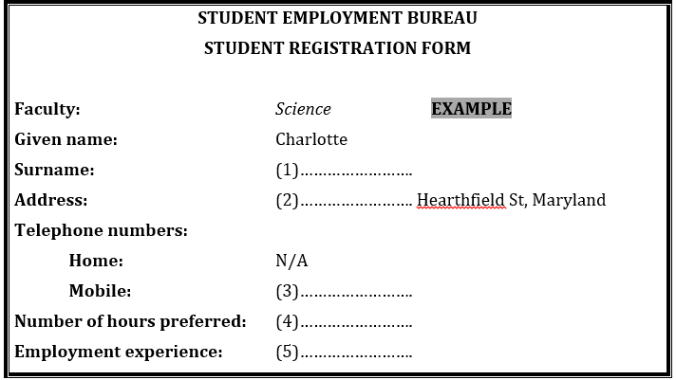
Questions 6 – 8. Circle the correct letter A – C
6. What time should Annetta finish work in the hamburger shop?
A. 7.00 pm B. 3.00 am C. 11.00 pm
7. What is the problem with Annetta’s pay at the hamburger shop?
A. the pay is too much B. the pay is late C. the pay isn’t correct
8. How many children will Annetta have to look after?
A. two boys and a girl B. two boys and two girls C. two girls and a boy
Questions 9 – 10. Label the map, choosing your answers from the list below. Write the correct letters A – E on the map.
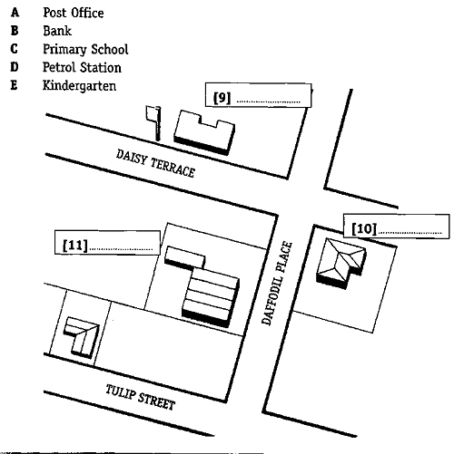
II. PRONUNCATION
Circle the word that has the underlined part pronounced differently from the rest.
1. A. dolphin B. honest C. lost D. occasion
2. A. works B. stays C. discovers D. bans
3. A. photograph B. phobia C. Stephen D. Philippines
4. A. missing B. scissors C. messenger D. massage
5. A. established B. recognized C. orphaned D. endangered

III. LEXICO-GRAMMAR
Exercise 1: Choose the most suitable option to fill in the blank.
1. When was Cuc Phuong forest _________Cuc Phuong National Park?
A. built B. named C. born D. developed
2. Unfortunately, about 5000 species of plants and animals are already being ________ each year.
A. eliminated B. developed C. visited D. found
3. Without plants, water would run off and take away________ soil.
A. poisonous B. bad C. forest D. valuable
4. __________ of our poor condition, we tried to cure the injured dolphin.
A. Despite B. Because C. In spite D. Although
5. Look at that girl swimming ___________ the sea.
A. on B. under C. across D. in
Exercise 2: Read the passage below and put the words in capitals into the correct forms to complete the passage.
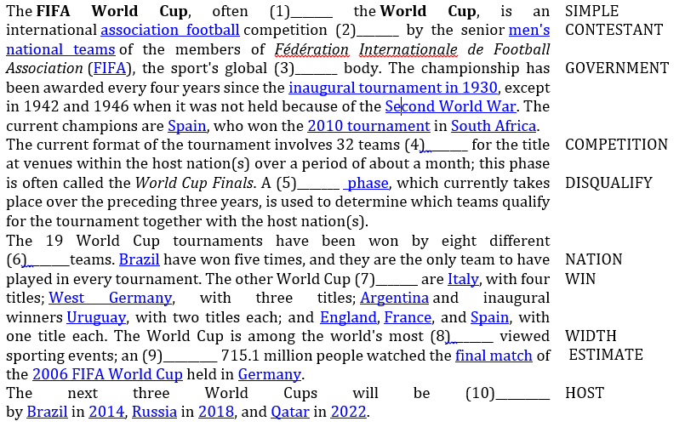
Exercise 3: Choose the option that has the same meaning as the underlined word/phrase above.
1. Try to eliminate fatty foods from your diet.
A. limit B. prevent C. get rid of D. add
2. The cattle drank from a river polluted with toxic chemicals.
A. waste B. colorless C. odorless D. poisonous
3. Whales feed on krill.
A. tiny shellfish B. small animals C. sea plants D. small fish
4. Sperm whale populations are at risk due to hunting.
A. in extinction B. in danger C. on the decrease D. in fewness
5. We had an accidental meeting with an old friend at the party last night.
A. unpleasant B. unexpected C. unacceptable D. unlucky
Exercise 4: Choose the words or phrases that are not correct in Standard English.
1. Because the expense of traditional fuels, many countries have been investigating alternative sources of power.
A B C D
2. Sharks can detect minute electrical discharges come from their prey.
A B C D
3. The oceans contain many forms of life that has not yet been discovered.
A B C D
4. The song to that we listened last night was beautiful.
A B C D
5. Not only my teacher but also my close friend are here.
A B C D
IV. READING COMPREHENSION
Exercise 1: Read the text and choose the best answer.
Although both Luther Burbank and George Washington Carver drastically changed American agriculture and were close friends besides, their methods of working could hardly have been more dissimilar. Burbank’s formal education ended with high school, but he was inspired by the works of Charles Darwin. In 1872, on his farm near Lunenberg, Massachusetts, he produced his first “plant creation” – a superior potato developed from the Early Rose variety. It still bears his name. After moving to Santa Rosa, California, in 1875, Burbank created a stream of creations, earning the nickname “the plant wizard.” He developed new varieties of fruits, vegetables, flowers, and other plants, many of which are still economically important. He began his work some thirty years before the rediscovery of Gregor Mendel’s work on heredity, and while he did not participate in the developing science of plant genetics, his work opened the country’s eyes to the productive possibilities of plant breeding. However, the value of his contributions was diminished by his methods. He relied on his keen memory and powers of observation and kept records only for his own use. He thus thwarted attempts by other scientists to study his achievements.
Carver, on the other hand, was a careful researcher who took thorough notes. Born a slave, he attended high school in Kansas, Simpson College in Iowa, and Iowa State College, which awarded him a master’s degree. When the eminent black educator Booker T. Washington offered him a position at Tuskegee Institute in Alabama, he accepted. While Burbank concentrated on developing new plants, Carver found new uses for existing ones. He produced hundreds of synthetic products made from the soybean, the sweet potato, and especially the peanut, helping to free Southern agriculture from the tyranny of cotton.
1. What is the author’s main purpose in writing the passage?
A. To compare the products created by two agricultural scientists
B. To demonstrate how Carver and Burbank influenced American agriculture
C. To contrast the careers and methods of two scientists
D. To explain how Charles Darwin inspired both Carver and Burbank
2. The word drastically in bold is closest in meaning to___________.
A. dramatically B. initially C. unintentionally D. potentially
3. According to the passage, which of the following best describes the relationship between Burbank and Carver?
A. They were competitors. B. Carver was one of Burbank’s teachers.
C. Burbank invited Carver to work with him. D. They were personal friends.
4. It can be inferred that Burbank’s first “plant creation” is known as the___________.
A. Early Rose potato B. Burbank potato C. Lunenberg potato D. Wizard potato
5. The word his in bold refers to___________.
A. George Washington Carver’s B. Gregor Mendel’s C. Luther Burbank’s D. Charles Darwin’s
6. Which of the following a closest in meaning to the word thwarted in bold?
A. restored B. predated C. nurtured D. defeated
7. The word thorough in bold is closest in meaning to
A. complete B. general C. puzzling D. precise
8. The author implies that a significant difference between the techniques of Burbank and those of Carver is that___________.
A. while Carver kept careful research records, Burbank did not.
B. Carver popularized his achievements, but those of Burbank were relatively unknown
C. unlike Burbank, Carver concentrated mainly on developing new varieties of plants
D. Burbank bred both plants and annuls, but Carver worked only with plants
9. According to the passage, what school awarded Carver a master’s degree?
A. Simpson College B. Iowa State College C. Tuskegee Institute D. The University of Alabama
10. Carver developed new uses for all of the following crops EXCEPT _____.
A. cotton B. soybeans C. sweet potatoes D. peanuts
Exercise 2: Choose the best option to fill in the blank in the following passage.
Sleep
By the time we (1)________old age most of us have (2)________ twenty years sleeping. Yet nobody knows why we do it. Most scientists believe that by resting our bodies, we allow time for (3)________ maintenance work to be done. Any (4)________ that there is can be put right more quickly if energy isn’t being used up doing other things.
Sleep is controlled by certain chemicals. These build up during the day, eventually reaching peaks that cause tiredness. We can control the effects of these chemicals to some extent. Caffeine helps to (5)________us awake while alcohol and some medicines make us sleepy.
By using electrodes, scientists are able to (6)________what goes on in people’s heads while they sleep. They have (7)________ that when we first drop off everything slows down. The heart (8)________ more slowly and our breathing becomes shallow. After about 90 minutes our eyes start to twitch and we go into what is called REM (Rapid Eye Movement) sleep, which is a (9)________that we’ve started to dream .You have dreams every night, even if you don’t remember them. There are many theories about why we dream, none of them conclusive. A lot of people say they have to have eight hours’ sleep every night while others seem to (10)________on a lot less. One thing’s for sure – we all need some sleep. Going without it can have some very strange effects.
1. A. arrive B. become C. reach D. get
2. A. passed B. used C. occupied D. spent
3. A. essential B. elementary C. needed D. main
4. A. harm B. suffering C. damage D. hurt
5. A. stay B. maintain C. make D. keep
6. A. exhibit B. study C. work D. think
7. A. seen B. researched C. watched D. discovered
8. A. beats B. hits C. moves D. trembles
9. A. clue B. proof C. sign D. signal
10. A. manage B. need C. get D. deal
Exercise 3: Fill in each blank with the most suitable word.
Many of us are still unaware (1)_________or are indifferent to the need to preserve rare species. Some people argue that species have (2)_________dying out since life began. "So (3)_________ should we worry about them now?" (4)_________ ask. They calmly believe that others would take their place. What these people (5)_________not realize is that it will (6)_________ millions of years before a set of species is evolved to replace (7)_________ we are rapidly losing. These species are (8)_________national heritage. We should not let (9)_________die off. They (10)_________ be preserved for our descendants.
V. WRITING
Rewrite the following sentences so that they have the same meanings as the given above.
1. The students usually hold the concerts at the university.
The concerts _______________________.
2. “When will you return to your hometown, Tim?” She said to Tim.
She asked _______________________.
3. They were late for school because they missed the first train.
Because of _______________________.
4. We didn’t find out about the meeting until he phoned us.
Not until _______________________.
5. It is believed that the man was killed by terrorists.
The man _______________________.
Exercise 2: Mary is going to have a birthday party at 7 p.m. on Sunday. She asks you to go to the market to buy some fruits and sweets with her in the morning. You agree to help her. Write a confirmation letter responding to her request. Write at least 50 words. Write in the following form.
Dear Mary,
……………………………………………………………………………………………………………………………………………………………………………………………………………………………………………………………………………………………………
Love,
Elena
-------------THE END-----------
Thí sinh không được sử dụng tài liệu. Cán bộ coi thi không giải thích gì thêm.
Họ và tên thí sinh:…………………….………..…….…….….….; Số báo danh……………………

ĐÁP ÁN
Total: 100 points
I. LISTENING
(20 points: 2 points/each correct answer)
1. Johnstone | 2. 126 | 3. 0414847749 | 4. (about) 10 | 5. (Uncle’s) shop (work)
6. C | 7. B | 8. C | 9. A | 10. E & C
II. PRONUNCIATION (5 points: 1 point/each correct answer)
1. D | 2. A | 3. D | 4. B | 5. A

III. LEXICO-GRAMMAR (25 points)
Exercise 1: (5 points: 1 point/each correct answer)
1. B | 2. A | 3. D | 4. C | 5. D

Exercise 2: (10 points: 1 point/each correct answer)
1. SIMPLY | 2. CONTESSTED | 3. GOVERNING | 4. COMPETING | 5. QUALIFICATION
6. NATIONAL | 7. WINNERS | 8. WIDELY | 9. ESTIMATED | 10. HOSTED

Exercise 3: (5 points: 1 point/each correct answer)
1. C | 2. D | 3. A | 4. B | 5. B
Exercise 4: (5 points: 1 point/each)
1. A | 2. C | 3. C | 4. B | 5. C

IV. READING COMPREHESION (35 points)
Exercise 1: (10 points: 1 point/each correct answer)
1. C | 2. D | 3. C | 4. A | 5. B
6. A | 7. B | 8. D | 9. A | 10. A

Exercise 2: (10 points: 1 point/each correct answer)
1. C | 2. D | 3. A | 4. C | 5. D
6. B | 7. D | 8. A | 9. C | 10. A

Exercise 3: (10 points: 1 point/each correct answer)
1. of | 2. been | 3. why | 4. they | 5. do
6. take | 7. those | 8. our | 9. them | 10. should

V. WRITING (20 points)
Exercise 1: (5 points: 1 point/each correct answer)
1. The concerts are usually held at the university by the students
2. She asked Tim when he would return to his hometown.
3. Because of (their) missing the first train, they were late for school.
4. Not until he phoned us did we find out about the meeting.
5. The man is believed to have been killed by terrorists.

Exercise 2: (15 points)
The letter should be written in the form in informal style.
The letter should include:
- Expression about the birthday party
- Expression about the agreement to help and suggestion for the time and place to go to the market together
- Confirmation
Organization& presentation: 25%
Coherence & clarity: 50%
Expression: 25%

----------------THE END---------------

