ĐỀ THI ĐỀ XUẤT KÌ THI HSG TỈNH 10
MÔN: TIẾNG ANH
I. LISTENING
PART 1: Questions 1 – 11
Questions 1 – 5
Complete the form below. Write NO MORE THAN TWO WORDS OR A NUMBER for each answer.
STUDENT EMPLOYMENT BUREAU
STUDENT REGISTRATION FORM

Faculty:  Given name:  Surname:  Address:  Telephone numbers:  Home:  Mobile:  Number of hours preferred:  Employment experience: | Science EXAMPLE  Charlotte  (1)…………………….  (2)…………………….Hearthfield St, Maryland  N/A  (3)…………………….  (4)…………………….  (5)…………………….

Questions 6 – 8
Circle the correct letter A – C
6. What time should Annetta finish work in the hamburger shop?
A. 7.00 pm B. 3.00 am C. 11.00 pm
7. What is the problem with Annetta’s pay at the hamburger shop?
A. the pay is too much B. the pay is late C. the pay isn’t correct
8. How many children will Annetta have to look after?
A. two boys and a girl B. two boys and two girls C. two girls and a boy
Questions 9 – 11
Label the map, choosing your answers from the list below. Write the correct letters A – E on the map.
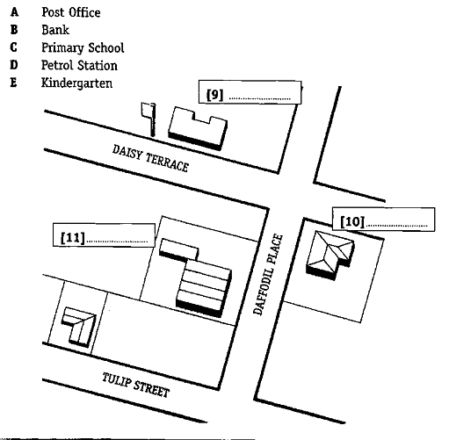
PART 2: Questions 12 – 20
For each question, there are three pictures and one short recording. Choose the correct picture and put a tick (√) in the box below it.
Example: How did the woman get to work?
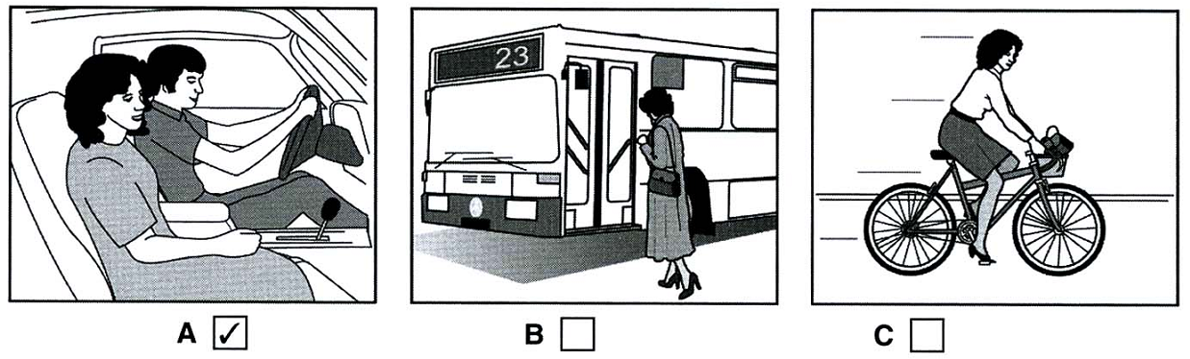
12. What regular exercise does David do at the moment?
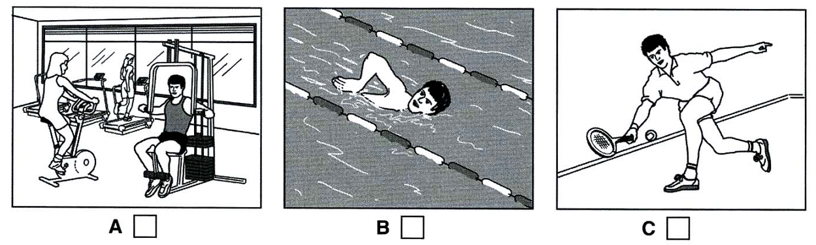
13. What should Suzie take to Emma’s house?
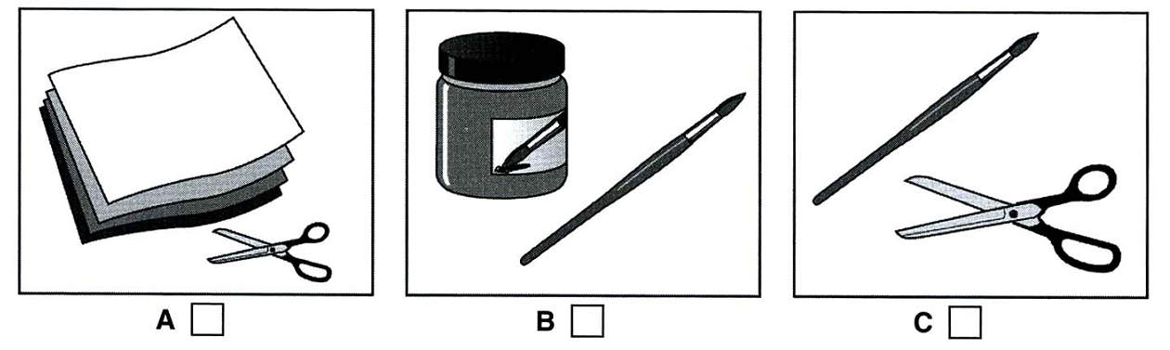
14. Which kind of T-shirt did the boy choose?
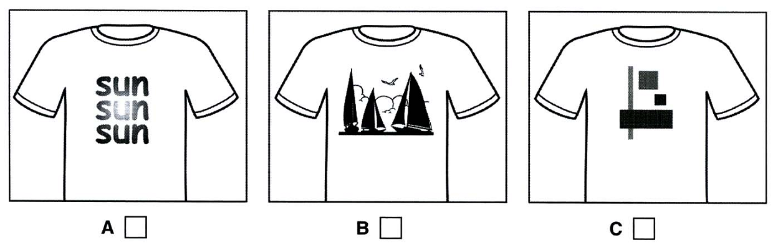
15. What frightened the man?
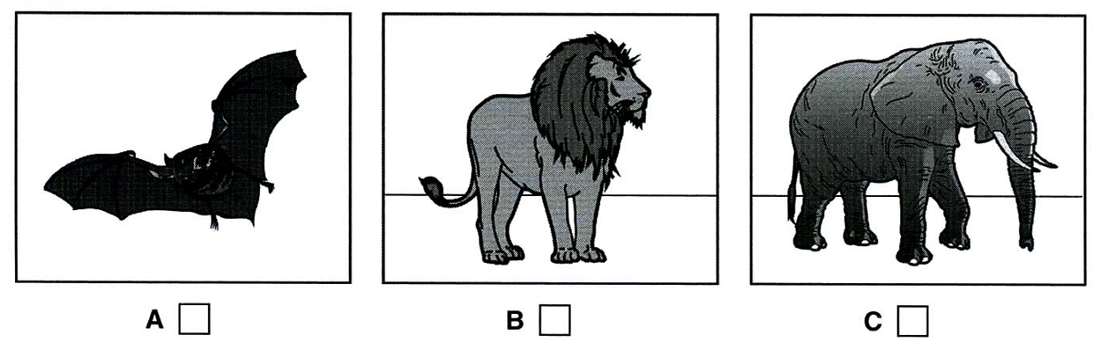
16. Where is the woman calling from?
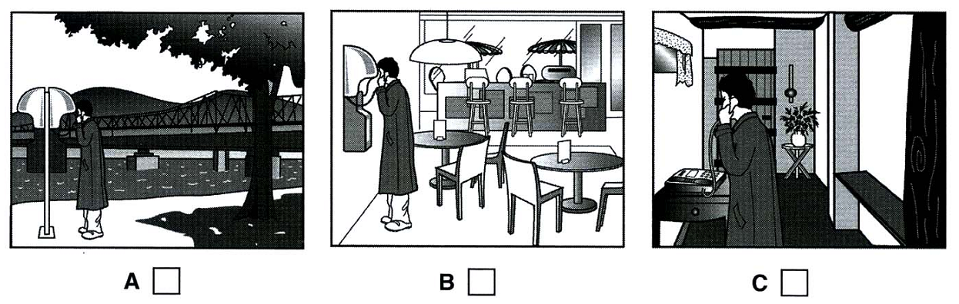
17. How did the woman spend her last holiday?
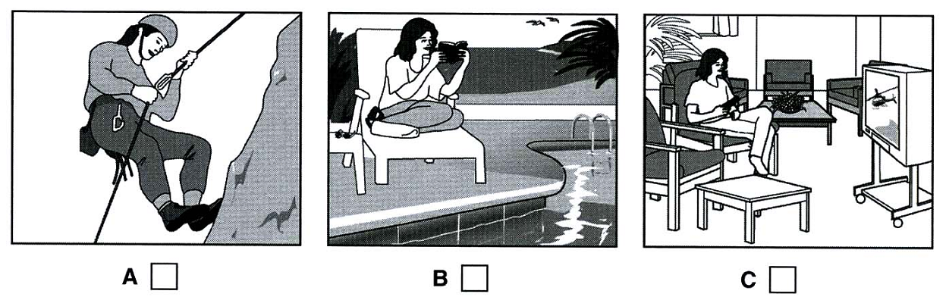
18. Where is the girl’s purse?
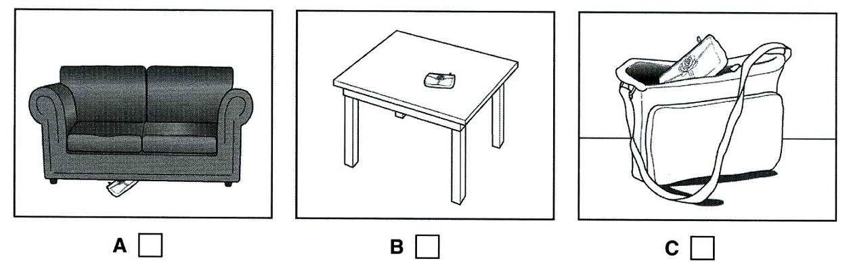
19. What is the man’s job now?
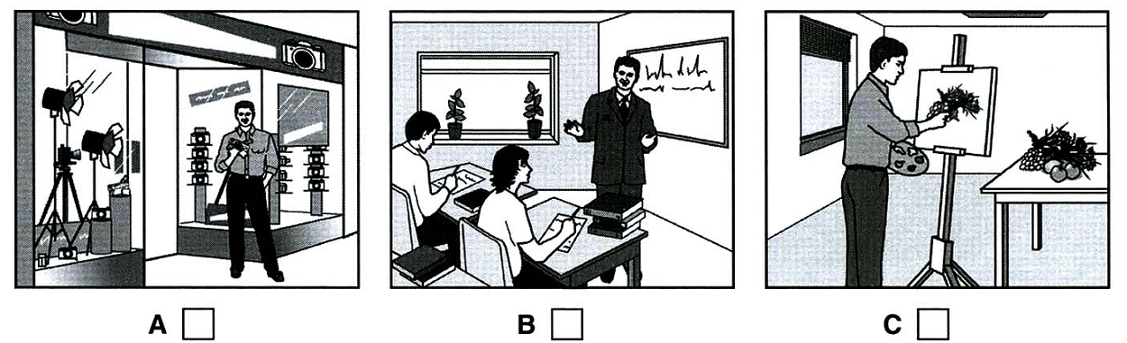
20. Which calendar will the boy buy?
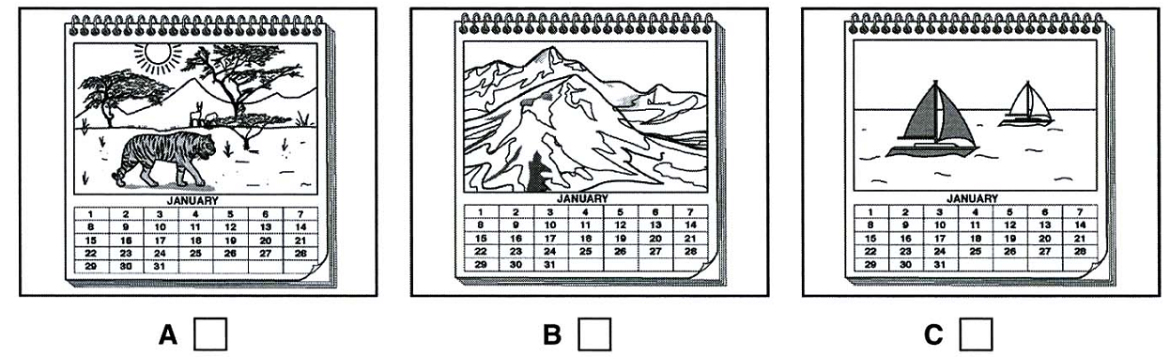
II. PRONUNCATION
Circle the word that has the underlined part pronounced differently from the rest.
1. A. dolphin B. honest C. lost D. occasion
2. A. works B. stays C. discovers D. bans
3. A. photograph B. phobia C. Stephen D. Philippines
4. A. missing B. scissors C. messenger D. massage
5. A. established B. recognized C. orphaned D. endangered

III. LEXICO-GRAMMAR
Exercise 1: Choose the most suitable option to fill in the blank.
- When was Cuc Phuong forest _________Cuc Phuong National Park?
A. built B. named C. born D. developed
- Unfortunately, about 5000 species of plants and animals are already being ________ each year.
A. eliminated B. developed C. visited D. found
- Without plants, water would run off and take away________ soil.
A. poisonous B. bad C. forest D. valuable
- __________ of our poor condition, we tried to cure the injured dolphin.
A. Despite B. Because C. In spite D. Although
- Look at that girl swimming ___________ the sea.
A. on B. under C. across D. in
- -A: ______________________. -B: I'd be glad to.
A. Would you like to drive me to class today? My car doesn’t start.
B. Would you please drive me to class today? My car doesn’t start.
C. Why don't you drive me to class today? My car doesn’t start.
D. What about driving me to class today? My car doesn't start.
- __________is a chemical used for killing weeds.
A. Pesticide B. Herbicide C. Fertilizer D. Antibiotic
- We all enjoyed the waters of Timor Sea and the coral reefs that lie __________.
A. under B. behind C. beneath D. beside
- Sperm whales are __________, which means they eat meat.
A. herbivores B. carnivores C. omnivores D. mammals
- You are _________ to clean the bathroom.
A. declared B. imagined C. supposed D. spoken
- There’s a _________ look on his face. I’m _________ of him indeed.
A. frightening/scared B. frightening/scaring
C. frightened/ scaring D. frightened/scared
- _________ Vietnamese are patriotic. Many were _________ heroes in the wars against foreign invaders.
A. x/x B. The/the C. x/the D. The/x
- “What would you like for your birthday?” – “________ will do.”
A. Anything B. None C. Something D. Somebody
- We have run out of water. – Really? Give me the bucket and I _______ some.
A. will fetch B. am going to fetch C. can fetch D. am fetching
- The band has gone on tour to ________ their new album.
A. increase B. strengthen C. promote D. spread
- I have a monthly bank _________ sent to me, so that I know how much there is in my account.
A. balance B. overdraft C. statement D. cheque
- The marshes provide a rich ___________ for water plants.
A. habitant B. inhabitant C. habitat D. habitation
- It upset him that nobody had __________ to tell him about it.
A. bothered B. even C. minded D. cared for
- Many children are being taught in __________ classes.
A. oversize B. oversized C. size over D. sized over
- The temperature has ________ by five degrees.
A. rose B. raised C. arose D. risen
Exercise 2: Choose the words or phrases that are not correct in Standard English and CORRECT them.
1. Because the expense of (B)traditional fuels, many countries (C)have been investigating alternative (D)sources of power.
2. Sharks (A)can detect minute (B)electrical discharges (C)come from (D)their prey.
3. The (A)oceans contain many (B)forms of life that (C)has not (D)yet been discovered.
4. (A)The song to (B)that we (C)listened last night (D)was beautiful.
5. (A)Not only my teacher (B)but also my close friend (C)are (D)here.
Exercise 3: Read the passage below and put the words in capitals into the correct forms to complete the passage.
The FIFA World Cup, often (1)_________ the World Cup, is an international association football competition (2)_________ by the senior men's national teams of the members of Fédération Internationale de Football Association (FIFA), the sport's global (3)_________ body. The championship has been awarded every four years since the inaugural tournament in 1930, except in 1942 and 1946 when it was not held because of the Second World War. The current champions are Spain, who won the 2010 tournament in South Africa.  The current format of the tournament involves 32 teams (4)_________ for the title at venues within the host nation(s) over a period of about a month; this phase is often called the World Cup Finals. A (5)_________ phase, which currently takes place over the preceding three years, is used to determine which teams qualify for the tournament together with the host nation(s).  The 19 World Cup tournaments have been won by eight different (6)_________teams. Brazil have won five times, and they are the only team to have played in every tournament. The other World Cup (7)_________ are Italy, with four titles; West Germany, with three titles; Argentina and inaugural winners Uruguay, with two titles each; and England, France, and Spain, with one title each.  The World Cup is among the world's most (8)_________ viewed sporting events; an (9)_________ 715.1 million people watched the final match of the 2006 FIFA World Cup held in Germany.  The next three World Cups will be (10)_________ by Brazil in 2014, Russia in 2018, and Qatar in 2022. | SIMPLE  CONTESTANT  GOVERNMENT  COMPETITION  DISQUALIFY  NATION  WIN  WIDTH  ESTIMATE  HOST
Exercise 4: Choose the option that has the same meaning as the underlined word/phrase above.
- Try to eliminate fatty foods from your diet.
A. limit B. prevent C. get rid of D. add
- The cattle drank from a river polluted with toxic chemicals.
A. waste B. colorless C. odorless D. poisonous
- Whales feed on krill.
A. tiny shellfish B. small animals C. sea plants D. small fish
- Sperm whale populations are at risk due to hunting.
A. in extinction B. in danger C. on the decrease D. in fewness
- We had an accidental meeting with an old friend at the party last night.
A. unpleasant B. unexpected C. unacceptable D. unlucky

IV. READING COMPREHENSION
Exercise 1:
The people below all want to find a radio programme they could enjoy listening to this week. Decide which programme would be the most suitable for the following people by marking the correct letter (A-H) next to the number (1-5) on your answer sheet. Note that there are more radio programmes than needed.
1. Roberta and Alice are interested in pop music. They want to listen to a live performance, and would also enjoy hearing interviews with some of the performers.
2. Paul enjoys listening to good modern drama. He works long hours during the week so he can only listen to the radio at weekends.
3. Sven teaches history and likes listening to experts talking about his subject. However, he hates shows which invite listeners to phone in.
4. Al writes poetry, and enjoys hearing other writers read their poems on the radio. He wants to have the opportunity to give his own opinions live on the programme.
5. Kim and Yannis are interested in finding out about the latest international events. They want to listen to a programme that is on every day.
RADIO PROGRAMME WE RECOMMEND THIS WEEK
A. Before Our Time  On Saturday, this weekly programme includes the first part of a documentary series about the discovery of the site of a 15th-century village. Professor John Frost and his team will talk about what life was like for the villagers.  C. Good Morning  This programme has regular reports on current affairs and news stories as they happen at home and abroad, plus discussions every morning about the background to world news. All this week, the programme features interviews with ordinary people around the world who talk about the recent history of their country.  E. Spotlight  This Thursday, writer Kate Dyer talks about the relationship between her poetry and her work as a history teacher. Kate will perform her latest poem, ‘Sunshine’. Listeners can then phone in and talk to Kate about her work. Dramatist David Fry will also talk about his latest book on historical drama from the 19th century.  G. Out and About  Hear all the latest in the world of pop and rock, including a week of major concerts as they happen every evening, coming direct from Birmingham. After each concert, listeners can also hear members of the band answering questions about their music. |  | B. Pop Review  This Saturday’s programme discusses the very latest CD releases, so there will be a great mix of music from all over the world. This week’s special report comes from Senegal.  D. History Team  This Wednesday, a local team tries to prove that people lived in the rocky hills of their area thousands of years ago. Specialist presenter Dr Clive Sparky describes what they find. Listeners can ring in and ask him questions, and discuss their own interests and local discoveries.  F. Opinion  Find out about the news on this regular Wednesday morning programme, with a team of journalists discussing the major events of the week around the world. this week, the programme also visits the new National Library’s collection of original documents from the world of literature, including internationally famous drama and poetry, with readings of some of the poems.  H. Showtime  This is a perfect programme for lovers of new plays, music and poetry. On Saturday, listeners have the chance to hear the prize-winning play ‘Machines’. Poet Roger Brookes will also read from his new collection ‘Rainbow’ and composer Jack Williams will play his latest piece for classical guitar.
Exercise 2: Read the text and choose the best answer.
Although both Luther Burbank and George Washington Carver drastically changed American agriculture and were close friends besides, their methods of working could hardly have been more dissimilar. Burbank’s formal education ended with high school, but he was inspired by the works of Charles Darwin. In 1872, on his farm near Lunenberg, Massachusetts, he produced his first “plant creation” – a superior potato developed from the Early Rose variety. It still bears his name. After moving to Santa Rosa, California, in 1875, Burbank created a stream of creations, earning the nickname “the plant wizard.” He developed new varieties of fruits, vegetables, flowers, and other plants, many of which are still economically important. He began his work some thirty years before the rediscovery of Gregor Mendel’s work on heredity, and while he did not participate in the developing science of plant genetics, his work opened the country’s eyes to the productive possibilities of plant breeding. However, the value of his contributions was diminished by his methods. He relied on his keen memory and powers of observation and kept records only for his own use. He thus thwarted attempts by other scientists to study his achievements.
Carver, on the other hand, was a careful researcher who took thorough notes. Born a slave, he attended high school in Kansas, Simpson College in Iowa, and Iowa State College, which awarded him a master’s degree. When the eminent black educator Booker T. Washington offered him a position at Tuskegee Institute in Alabama, he accepted. While Burbank concentrated on developing new plants, Carver found new uses for existing ones. He produced hundreds of synthetic products made from the soybean, the sweet potato, and especially the peanut, helping to free Southern agriculture from the tyranny of cotton.
1. What is the author’s main purpose in writing the passage?
(A) To compare the products created by two agricultural scientists
(B) To demonstrate how Carver and Burbank influenced American agriculture
(C) To contrast the careers and methods of two scientists
(D) To explain how Charles Darwin inspired both Carver and Burbank
2. The word drastically in bold is closest in meaning to
(A) dramatically (B) initially (C) unintentionally (D) potentially
3. According to the passage, which of the following best describes the relationship between Burbank and Carver?
(A) They were competitors.
(B) Carver was one of Burbank’s teachers.
(C) Burbank invited Carver to work with him.
(D) They were personal friends.
4. It can be inferred that Burbank’s first “plant creation” is known as the
(A) Early Rose potato (B) Burbank potato
(C) Lunenberg potato (D) Wizard potato
5. The word his in bold refers to
(A) George Washington Carver’s (B) Gregor Mendel’s
(C) Luther Burbank’s (D) Charles Darwin’s
6. Which of the following a closest in meaning to the word thwarted in bold?
(A) Restored (B) Predated (C) Nurtured (D) Defeated
7. The word thorough in bold is closest in meaning to
(A) complete (B) general (C) puzzling (D) precise
8. The author implies that a significant difference between the techniques of Burbank and those of Carver is that
(A) while Carver kept careful research records, Burbank did not
(B) Carver popularized his achievements, but those of Burbank were relatively unknown
(C) unlike Burbank, Carver concentrated mainly on developing new varieties of plants
(D) Burbank bred both plants and annuls, but Carver worked only with plants
9. According to the passage, what school awarded Carver a master’s degree?
(A) Simpson College (B) Iowa State College
(C) Tuskegee Institute (D) The University of Alabama
10. Carver developed new uses for all of the following crops EXCEPT
(A) cotton (B) soybeans (C) sweet potatoes (D) peanuts
Exercise 3: Choose the best option to fill in the blank in the following passage.
Sleep
By the time we (1)________old age most of us have (2)________ twenty years sleeping. Yet nobody knows why we do it. Most scientists believe that by resting our bodies, we allow time for (3)________ maintenance work to be done. Any (4)________ that there is can be put right more quickly if energy isn’t being used up doing other things.
Sleep is controlled by certain chemicals. These build up during the day, eventually reaching peaks that cause tiredness. We can control the effects of these chemicals to some extent. Caffeine helps to (5)________us awake while alcohol and some medicines make us sleepy.
By using electrodes, scientists are able to (6)________what goes on in people’s heads while they sleep .They have (7)________ that when we first drop off everything slows down. The heart (8)________ more slowly and our breathing becomes shallow. After about 90 minutes our eyes start to twitch and we go into what is called REM (Rapid Eye Movement) sleep, which is a (9)________that we’ve started to dream .You have dreams every night, even if you don’t remember them. There are may theories about why we dream, none of them conclusive. A lot of people say they have to have eight hours’ sleep every night while others seem to (10)________on a lot less . One thing’s for sure – we all need some sleep. Going without it can have some very strange effects.
1. A. arrive B. become C. reach D. get
2. A. passed B. used C. occupied D. spent
3. A. essential B. elementary C. needed D. main
4. A. harm B. suffering C. damage D. hurt
5. A. stay B. maintain C. make D. keep
6. A. exhibit B. study C. work D. think
7. A. seen B. researched C. watched D. discovered
8. A. beats B. hits C. moves D. trembles
9. A. clue B. proof C. sign D. signal
10. A. manage B. need C. get D. deal
Exercise 4: Fill in each blank with the most suitable word.
Many of us are still unaware (1)_________or are indifferent to the need to preserve rare species. Some people argue that species have (2)_________dying out since life began. "So (3)_________ should we worry about them now?" (4)_________ ask. They calmly believe that others would take their place. What these people (5)_________not realize is that it will (6)_________ millions of years before a set of species is evolved to replace (7)_________ we are rapidly losing. These species are (8)_________national heritage. We should not let (9)_________die off. They (10)_________ be preserved for our descendants.

V. WRITING
Exercise 1: Rewrite the following sentences so that they have the same meanings as the given above.
- The students usually hold the concerts at the university.
The concerts ……………………………………………...……….
- “When will you return to your hometown, Tim?” She said to Tim.
She asked …………………………………………………………
- They were late for school because they missed the first train.
Because of …………………………………………………………..
- We didn’t find out about the meeting until he phoned us.
Not until …………………………………………………………..
- He may spend the holiday in Japan when he saves enough money but I don’t think he can save enough money.
If ……………………………………………………………………..
- It is believed that the man was killed by terrorists.
The man ……………………………………………………………..
- He was drunk last night because he joined the party.
If ……………………………………………………………………..
- I think you were wrong when you asked your friend for helping you in your test.
If I ……………………………………………………………………..
- There are no interesting films on this week.
There is nothing ……………………………………………………………..
- This kind of food has a really delicious taste.
This kind of food tastes ……………………………………………………..
Exercise 2:
Mary is going to have a birthday party at 7 p.m. on Sunday. She asks you to go to the market to buy some fruits and sweets with her in the morning. You agree to help her. Write a confirmation letter responding to her request. Write at least 50 words. Write in the following form.
Dear Mary,
…………………………………………………………………………………………………………………………………………………………………………………………………………………………………………………………………………………………………………………………………………………………………………
Love,
Elena
ĐÁP ÁN
I. LISTENING
PART 1 (11 points: 1 point/each correct answer)
1. Johnstone
2. 126
3. 0414847749
4. (about) 10
5. (Uncle’s) shop (work)
6. C
7. B
8. C
9. A
10. E
11. C

PART 2 (9 points: 1 point/each correct answer)
12. B
13. C
14. C
15. A
16. C
17. B
18. C
19. B
20. C

II. PRONUNCIATION (2.5 points: 0.5 point/each correct answer)

1. D
2. A
3. C
4. B
5. A

III. LEXICO-GRAMMAR (22.5 points)
Exercise 1: (10 points: 0.5 point/each correct answer)
1. B
2. A
3. D
4. C
5. D
6. B
7. B
8. C
9. C
10. C
11. A
12. D
13. A
14. A
15. C
16. C
17. C
18. A
19. B
20. D

Exercise 2: (5 points: 0.5 point/each finding + 0.5 point/each correcting)
- A => because of
- C => coming
- C => have
- B => which
- C => is
Exercise 3: (5 points: 0.5 point/each correct answer)

- simply
- contested
- governing
- competing
- qualification
- national
- winners
- widely
- estimated
- hosted

Exercise 4: (2.5 points: 0.5 point/each correct answer)

1. C
2. D
3. A
4. B
5. B

IV. READING COMPREHESION (35 points)
Exercise 1: (5 points: 1 point/each correct answer)

1. G
2. H
3. A
4. E
5. C

Exercise 2: (10 points: 1 point/each correct answer)
1. C
2. A
3. D
4. B
5. C
6. D
7. A
8. A
9. B
10. A

Exercise 3: (10 points: 1 point/each correct answer)

1. C
2. D
3. A
4. C
5. D
6. B
7. D
8. A
9. C
10. A

Exercise 4: (10 points: 1 point/each correct answer)

1. of
2. been
3. why
4. they
5. do
6. take
7. those
8. our
9. them
10. should

V. WRITING (20 points)
Exercise 1: (10 points: 1 point/each correct answer)
- The concerts are usually held at the university by the students
- She asked Tim when he would return to his hometown.
- Because of (their) missing the first train, they were late for school.
- Not until he phoned us did we find out about the meeting.
- If he could save/saved enough money, he might/would spend the holiday in Japan.
- The man is believed to have been killed by terrorists.
- If he hadn’t joined the party, he wouldn’t have been drunk last night.
- If I were you, I wouldn’t have asked my friend for helping me in my test.
- There is nothing interesting on at the cinema/on TV this week.
- This kind of food tastes really delicious.
Exercise 2: (10 points)
The letter should be written in the form in informal style.
The letter should include:
- Expression about the birthday party
- Expression about the agreement to help and suggestion for the time and place to go to the market together
- Confirmation
- Organization& presentation: 25%
- Coherence & clarity: 50%
- Expression: 25%

Total: 100 points

