UNIT 7 TRAFFIC

A. PHONETICS

I. Write the sound /e/ or /eI/ of the underlined letter(s)

1. train / /  2. seatbelt / /  3. mistake / /  4. helmet / /  5. way / / | 6. left / /  7. ahead / /  8. station / /  9. helicopter / /  10. pavement / / | 11. sail / /  12. safety / /  13. railway / /  14. brake / /  15. pedestrian / / | 16. healthy / /  17. plane / /  18. great / /  19. record / /  20. said / /
II. Underline the words having the sound /e/ and circle the words having the sound /eI/ in the sentences below. Then read the sentences aloud.

1. Which one is better, train or plane?
2. Great! This is the best way to the railway station.
3. Let’s take a break and have some fresh bread!
4. For your safety, you must obey the traffic rules when driving.
5. Jane was standing on the pavement waving her friends.
6. The wet weather is expected to continue in central valley.
7. I sat waiting patiently for the wedding to end.

III. Find the word which has the different sound in the underlined part.

1. a. break | b. bread | c. instead | d. health
2. a. lane | b. stay | c. traffic | d. wait
3. a. record | b. vehicle | c. lesson | d. zebra
4. a. jam | b. narrow | c. carry | d. danger
5. a. means | b. great | c. seatbelt | d. teacher
B. VOCABULARY AND GRAMMAR

I. Write the means of transport under the correct pictures

bike | plane | truck | train | ship motorbike
car | boat | bus | subway | helicopter van

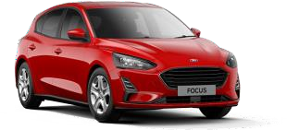  1………………… |  |  | 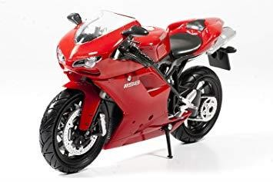  2………………. | 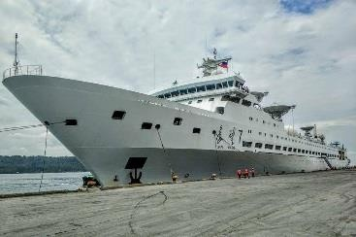  3……………….
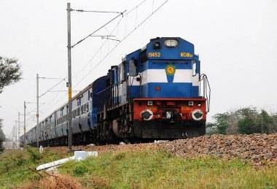 |  |  | 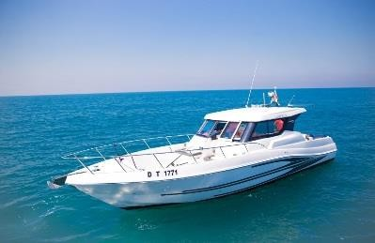 | 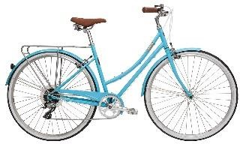
 | 4…………………. | 5………………… |  |  | 6…………………
 | 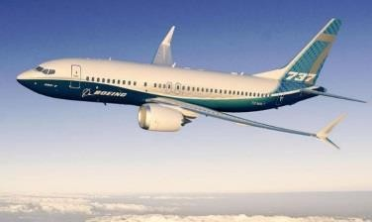  7……………….. | 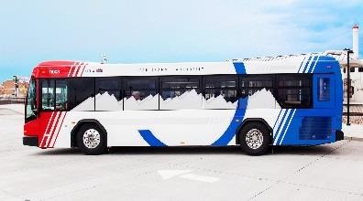  8………………….. |  |  | 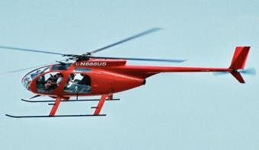  9……………….
 | 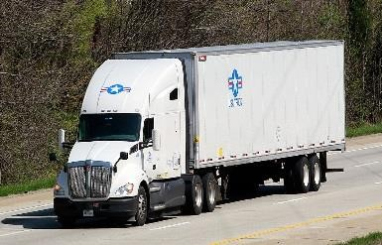  10……………… | 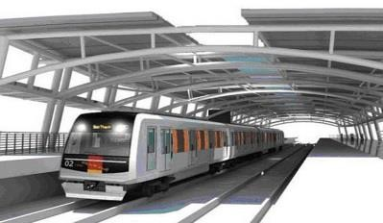  11……………….. |  |  | 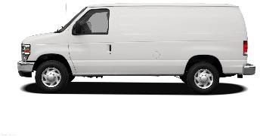  12………………..

II. Match the words in part 1 with definitions.

1. A large, heavy vehicle with wheels. It is used for carrying goods.
2. A vehicle with two wheels that you ride by pushing its pedals with your feet
3. A vehicle that has two wheels and an engine.
4. A large machine that runs along a railway line. It can carry many people.
5. A very large boat used for carrying people or goods across the sea.
6. A aircraft with large metal blades on top that spin and lift it into the air.
7. A vehicle that flies in the sky and has wings and one or more engine.
8. A large vehicle with lots of seats. It carries passengers from one place to another.
9. A small vehicle that travels on water, moved by oars, sails or a motor.
10. A railway system that runs under the ground below a big city.

III. Complete the sentences with the correct tense or form of the verbs from the box.
ride
drive fly sail cycle
reverse
get on
get off

1. My uncle used to be a pilot. He helicopters.
2. a number 73 bus. That will take you to Islington High Street.
3. He into a lamppost and damaged the back of the car.
4. When being stuck in a traffic jam, some people their motorbikes on the pavement.
5. The old man got into a Rolls Royce and away.
6. I will get myself a little boat and it around the world.
7. When we reach the next stop, we’ll .
8. In the afternoon, Mai usually round the lake near her house.

IV. Fill in the each gap with an expression in the box.
plane tickets zebra crossings driving licence traffic jam speed limit
cycle helmet means of transport
road safety
railway station
road sign
1. Be careful! The says “No U-Turn”.
2. You ran through the stop sign. May I see your _ , please?
3. It is the law that motorists give way to pedestrians at .
4. You can book your online, by phone, or through a travel agent.
5. Slow down – the on this road is 60 mph.
6. We were stuck in a on the freeway for two hours.
7. When we got to the the train had left.
8. What did they use at that time? – horses
9. is taught to young children to avoid road accidents.
10. You should wear a _ when riding a bike.

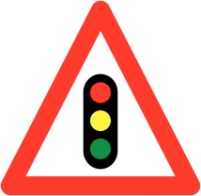
V. What do these signs mean? Choose the correct answers.

1. | a. Traffic lights ahead  b. Stop at the traffic lights  c. No traffic lights on this road | 2.  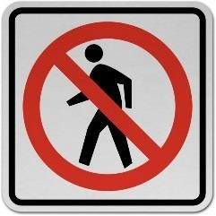 | a. Walking only  b. No crossing the street  c. No pedestrians.
3.  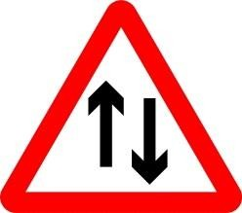 | a. Two-way traffic ahead  b. One-way road  c. Road narrows | 4.  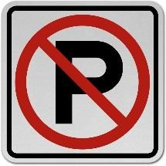 | a. No playing in the street  b. No parking allowed  c. No pedestrian traffic
5.  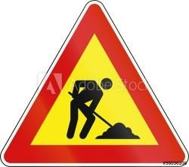 | a. Trash removal nearby  b. workers on this road  c. road works ahead | 6.  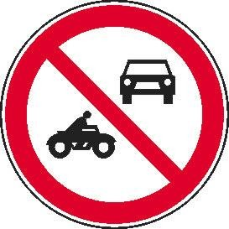 | a. No entry for motor vehicles  b. Give way to traffic  c. Only cars and motorbikes allowed
7.  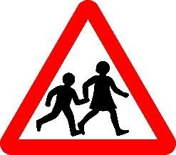 | a. School crossing ahead  b. Pedestrians only  c. Crosswalk ahead | 8  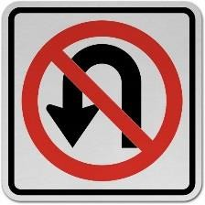 | a. No left turn  b. U-turn is prohibited  c. U-turn allowed
9.  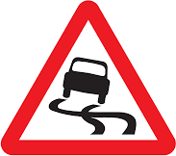 | a. Slippery road  b. Oil on road  c. Road curves ahead | 10.  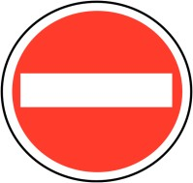 | a. Stop here  b. One lane traffic  c. No entry
11.  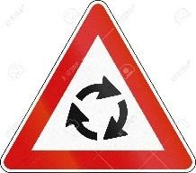 | a. All vehicles turn back  b. Roudabout ahead  c. Turn left only | 12.  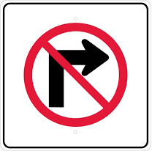 | a. No right turn  b. Go straight ahead on red  c. No turn right on red
VI. Complete the sentences with can, must or mustn’t
1. | 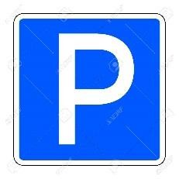 |  | You park here.
2. | 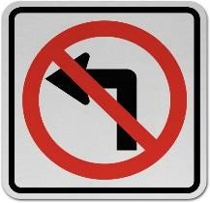 |  | You turn left.
3. | 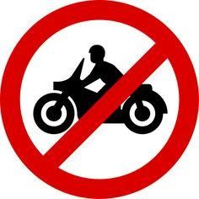 |  | You ride your motorbike on this road.
4. | 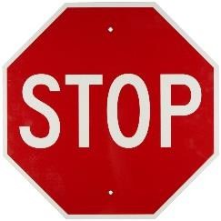 |  | You stop.
5. | 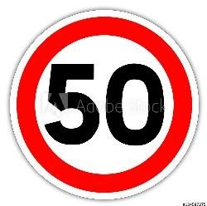 |  | You drive more than 50 km/h.
6. | 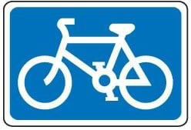 |  | Only cyclists enter this lane.
7. |  |  | You go ahead or turn right.
8. |  |  | You make a U-Turn here.
9. |  |  | You give way.
10. |  | 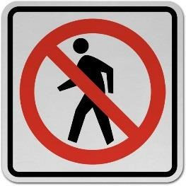 | Pedestrians enter.

VII. Complete the sentences with used to or didn’t use to and the verbs in the box.
play wash be eat like travel live work read get up

1. I in the countryside when I was a child.
2. My mother coffee but now she loves it.
3. Julian much, but Harry Potter changed his attitude.
4. Dave in a football team but now he plays basketball.
5. The children early because they had to get to school at 7 o’clock.
6. The shop so crowded as it is nowadays.
7. In those days, people all their clothes by hand.
8. I in a restaurant before I went to college.
9. People so much junk food, their diet was healthier.
10. When my father was young, he abroad so much.

VIII. Write sentences, using the prompts and then correct form of used to.
1. We/ live in a flat when I was a child.

2. People/ not have/ mobile phones 20 years ago.

3. Jim/ go/ swimming every weekend?

4. My father/ smoke/ but he gave up five years ago.

5. Lily/ not cook/ much, but now she makes dinner every day.

6. There/ be/ a supermarket on the corner?

7. People/ not buy/ so much stuff as they do today.

8. You/ play football or basketball at school?

9. I/ go/ to bed very late but not anymore!

10. Which TV programme/ you/ watch/ most/ when you were little?

IX. Complete the dialogue with the correct form of used to

John: Sally:  John: Sally:  John: Sally: | What (1) _ (you/ be) like when you were a child?  I (2) (wear) very thick glasses, and I(3) (be) quite short. To be honest, I (4) (not like) myself very much.  What (5) _ (you/do) for fun?  Oh, we (6) (not have) phones or technology of any kind and the streets (7) (be) safer than now, so we (8) (play) outdoors all the time.  (9) (you/get) good marks in school? Yes, I (10) (study) very hard.
X. Choose the correct answers.
1. I a lot when I was younger.
a. use to swim b. used to swim
c. used to swimming d. didn't used to swim
2. People so often, or they just didn't travel at all.
a. used to travel b. used not to travel
c. didn't used to travel d. didn’t use to travel
3. My brother _ his leg in a car accident when he was 20.
a. broke b. used to break c. uses to break d. breaks
4. long hair when you were a teenager?
a. Used you to have b. Did you used to have
c. Did you use to have d. Are you used to having
5. My Grandpa never coffee. He always drank tea.
a. uses to like b. used to like c. didn't use to like d. is used to like
6. She as a teacher for many years before she became a writer
a. didn't use to work b. used to worked c. used to work d. worked
7. There a bus station there. When was it built?
a. used to be b. usedn't to be c. didn't use to be d. used not being
8. Dominic to bed late on Fridays and Saturdays.

a. usually goes b. uses to go c. doesn't use to go d. is used to go
9. What kind of music when she was a child?

a. Nancy used to like b. used Nancy to like
c. did Nancy used to like d. did Nancy use to like
10. He several books a month, but he doesn't have time any more.
a. usually reads b. used to read c. used to reading d. didn't use to read

XI. Write sentences with it, using the cues given.
Example: 700 metres/ my house/ gym
It is about 700 metres from my house to the gym.
1. 150 million kilometres/ Earth/ sun

2. 105 km/ Hanoi/ Hai Phong.

3. 500 metres/ my house/ my school

4. 170 km/ Quy Nhon City/ Pleiku City

5. not very far/ here/ Tan Son Nhat Airport

6. a long way to go/ Hue/ Ho Chi Minh city

XII. Write sentences, using the cues given. Example: your house/ school/ 2 kilometres/ go/ bike. A: How far is it from hour house to school?
B: It’s about 2 kilometres.
A: How do you go to school? B: I go to school by bike.
1. your village/ the town/10 kilometres/ travel/ motorbike
A:
B:
A:
B:
2. Nga’s house/ her grandparents’ house/ 700 metres/ go/ foot
A:
B:
A:
B:
3. your hometown/ Ho Chi Minh city/ 900 kilometres/ travel/ train
A:
B:
A:
B:
4. Jim’s office/ the restaurant/ not very far/ go/ walk
A:
B:
A:
B:

VIII. Fill in each blank with an appropriate preposition
1. Mai used to go to school food when she was primary school.
2. My father usually travels to Hanoi plane.
3. Mai often cycles round the lake Saturday morning.
4. What are you doing the weekend?
5. We were stuck a traffic jam for over two hours.
6. How far is your school your house?
7. I got at the wrong stop and had to wait another bus.

8. Yesterday I saw a horrible accident

9. Many years ago, people didn't use to be worried
my way home from school.
traffic jams.

10. It's illegal women to drive Saudi Arabia .

C. SPEAKING
I. Write questions for the underlined parts

Ann: Huan: Ann: Huan: Ann: Huan: Ann: Huan: Ann: Huan: Ann: Huan: Ann: Huan: Ann: Huan: Ann:  Huan: | Hi Huan! (1)  I came to class late this morning because I was stuck in a traffic jam. Really? (2)  Yes, my house is rather far from school  (3)  Um...about 5 kilometres  (4)  I go to school by bike.  (5)  It takes me about 30 minutes. And it takes longer when the traffic is jammed. (6)  I get stuck in a traffic jam once or twice a week.  (7)  I often get stuck in a traffic jam on Monday morning.  (8)  I usually go to school at 6.15.  So why don't you start to school a little earlier on Monday? Okay, I'll try

II. Put the dialogue into the correct order.
Oh, I thought I could make a right turn on red here.
Here's your ticket. Please drive safely, ma'am.
Thank you, sir.
_1_ Sir, did I do anything wrong?
No, ma'am. The sign says "No Turn on Red."
Yes, ma'am. Didn't you see the red light?
May I see your driver's license and insurance policy, please? I have to give you a ticket.
Oh, I guess I didn’t see it.
Here they are
Have a nice day, ma’am.
D. READING

I. Fill in each blank with a word from the box
safest vehicles only far crossroad follow across reason

Children have a tendency to run very fast (1) the street, or choose any spot to cross because it may seem empty, or approaching vehicles may be (2) away. That can be dangerous as passing (3) do not slow down unless there is a signal or a crossroad. This is the
(4) why pedestrian crossings and intersections are the (5) places to cross. Children should cross (6) at an intersection and use the pedestrian crossing. If they are in a small neighborhood where there is no (7) should (8) the rule 'stop, look both ways and cross'.

II. Read the text carefully, then do the tasks.
THE FIRST ELECTRIC TRAFFIC LIGHTS
In the early 1900's, the world was developing at a very rapid pace, and with the growth of industrialization, cities became more crowded. Furthermore, with the invention automobiles, the traffic on the roads increased significantly, so there was a need for a better traffic system.
In 1912, an American policeman, Lester Wire, who was concerned with the increasing traffic, came up with the idea of the first electric traffic light. Based on Wire's design, the lights were first installed in Cleveland, Ohio, on August 5, 1914, at the corner of 105th and Euclid Avenue
The first electric traffic light had only red and green lights; it did not have a yellow light like modern- day traffic signals. Instead of a yellow light, it had a buzzer sound that was used to indicate that the signal would be changing soon.
In the year 1920, a policeman named William Potts in Detroit, Michigan invented the first four-way and three-coloured traffic lights. Apart from red and green, a third colour - amber (or yellow)
- was introduced. Detroit became the first city to implement the four-way and three-colored traffic lights. In the 1920's, several automated traffic signals were installed in major cities around the world. The modern traffic light still uses this famous T-shaped model with three different colors.

A. Decide whether the following sentences are true (T) or false (F).
1. Due to the invention of cars, the traffic on the roads increased rapidly.
2. The first electric traffic light was invented in 1914 by Lester Wire.
3. The first electric traffic light had red, green and amber lights.
4. The yellow light didn’t exist until the 1920s.
5. Detroit was the first city to use the red, yellow, and green lights to control road traffic.
6. The modern traffic light works on the same principle as Wire’s original light.

B. Answer the questions
1. When was the first electric traffic light invented?

2. Who invented the first electric traffic light?

3. How many colours did the first electric traffic light have?

4. Where were the lights first installed?

5. What was used instead of yellow light to warn everyone of a signal change?

6. When was the yellow light added?

E. WRITING

I. Arrange the words to make meaningful sentences.
1. big/ traffic congestion/ can/ what/ do/ to/ we/ reduce/ cities/ in?

2. is/ the/ your/ train station/ how/ hotel/ to/ far/ it/ from ?

3. my/ it/ not/ is/ far/ very/ house/ from/ to/ school.

4. think/ I/ it's/ time/ to/ do/ to/ reduce/ in/ something/ traffic jams/ Vietnam.

5. used/ school/ on/ Mai/ foot/ she/ to/ go/ to/ was/ in/ when/ primary school.

6 there/ city center/ traffic jams/ are/ the/ in/ rush hour/ often/ the/ in.

7. about/ people/ use/ in/ worry/ the past/ traffic/ didn't/ congestion/ to.

8. wear/ a/helmet/ compulsory/ is/ when/ in/ it/ to/ riding/ Vietnam/ a/ motorbike.

II. Complete the second sentences so that it has the same meaning as the first.
1. I went swimming every Thursday when I was at school.
I used
2. Mai walked to school when she was in primary school.
Mai went
3. Why don't we cycle to the town at the weekend?
How about ?
4. The distance between my house and the nearest bookstore is about 2 kilometres It
5. The airport is not far from the hotel.
The hotel is
6. What’s the distance from Madrid to Barcelona?
How
7. Turn left into Lavalle Street and then go straight ahead.
Make
8. Did your father use to drive to work?
Did your father use to travel ?
TEST FOR UNIT 7
I. Choose the word whose underlined part in pronounced differently from the rest.

1. a. breaking | b. great | c. steak | d. healthy
2. a. cycle | b. bicycle | c. fly | d. skyscraper
3. a. cycle | b. licence | c. vehicle | d. centre
4. a. reversed | b. walked | c. stopped | d. obeyed
5. a. park | b. pavement | c. plane | d. safety

II. Match the road signs with their meanings.
No Overtaking No Left Turn
Pedestrian Crossing Slippery Road
Crossroads
No
Parking Go Ahead Only Turn Right Railway Crossing Hospital Ahead

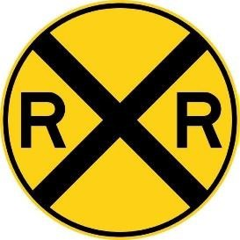
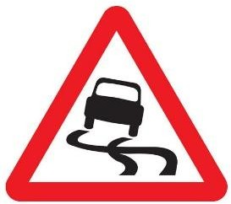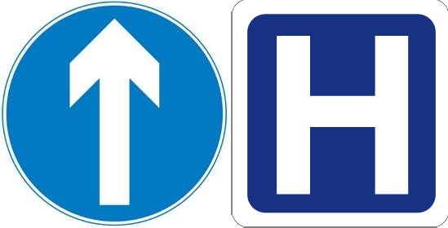

1.
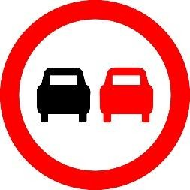
5.
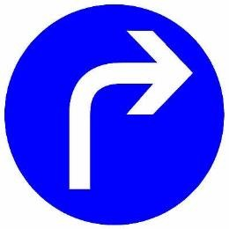
9.
2.
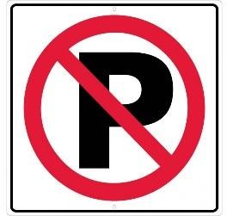
6.
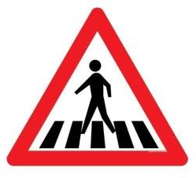
10.
3.

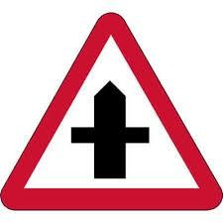
7.
4.
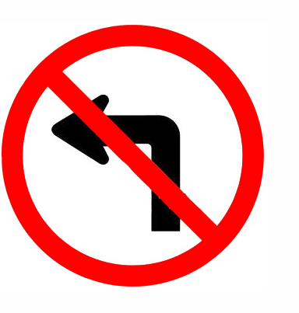
8.

III. Choose the best answer a, b, c or d to complete the sentence.
1. You should walk across the street the zebra crossing.
a. on b. at c. in d. from
2. My house is not far from my school, so I usually go .
a. on foot b. by foot c. by car d. by boat
3. This morning, I was _ in a traffic jam and got to school fifteen minutes late.
a. catch b. block c. struck d. stuck
4. Turn on the left turn before you make the turn and slow down.
a. sign b. direction c. signal d. crossing
5. It is to use a hand-held mobile phone while driving or riding.
a. safe b. important c. illegal d. careful
6. does it take you to ride to school? – About 30 minutes.
a. How long b. How far c. How often d. How much
7. A is a part of a road that only bicycles are allowed to use.
a. cycle cross b. cycle lane c. cycle line d. cycle race
8. You cross the street when the light is red.
a. should b. don’t have to c. can d. mustn’t
9. People produce as much rubbish as we do now.
a. use to b. used to c. used to not d. didn’t use to
10. “How far is Vung Tau from Ho Chi Minh City”-“ ”
A. It’s not very far b. it takes about two hours or more.
c. It’s about 120km d. You can get to Vung Tau by boat or bus.

IV. Write the correct from or tense of verbs in brackets.
1. (you/ ever/ drive) on the wrong side of the road?
2. My family (fly) back from our Hong Kong holiday two days ago.
3. Right now, the students (learn) road signs in the schoolyard.
4. Usually Oanh (walk) to school, but this week she (ride) her bike.
5. The driver was so drunk that he (lose) control of his car.
6. If I have enough money, I (buy) a racing car.
7. My father (teach) me to ride a bike when I was seven.
8. Transport used (be) much slower three hundred years ago.
9. Saudi women weren’t allowed _ (drive) a car until recently.
10. In South Africa, you have to let animals (go) first.

V. Supply the correct form of the words in brackets
1. Young children are expected to show to their parents. (obey)
2. When cycling on the roads, remember: first. (safe)
3. Children should avoid foods such as hamburger and chips. (health)
4. Most road accidents happen because the motorists drive . (care)
5. It is unsafe and to pass another vehicle on the left. (legal)
6. My was delayed for over two hours due to bad weather. (fly)
7. Everyone should obey traffic rules for their own safety. (strict)
8. The policeman the car to stop with a flashlight. (sign)
9. Signs with red circles are mostly - that means you can’t do something. (prohibit)
10. This sign indicates that traffic lights are ahead. (warn)

VI. There is one mistake in each sentence. Find and correct it.
1. I love Thai food now, but I didn’t used to like spicy food.
2. He can drive a bicycle with his hands off the handlebars.
3. We use to walk miles to school every day due to lack of public transport.
4. You are not allowed to drive faster than the number on a limit speed sign.
5. It about 1137 kilometres from Hanoi to Ho Chi Minh City.
6. Bicycles are a cheap and efficient mean of transport.
7. A sign within a red triangle will warn people for something.
8. Be careful when you are on roads. You must drive fast or carelessly!

VII. Match the questions with the correct answers.

1. How does your father travel to word?  2. May I see your driving license, please.  3. Sir, did I do anything wrong?  4. What took you so long?  5. What is the fastest means of transport?  6. How far is it from here to the railway station?  7. Could you tell me how to get to the nearest bus stop, please?  8. How long will it take to get there? | a. Oh, sorry sir, I don’t have it on me.  b. was stuck in a traffic jam.  c. Not very far. Just about 2 km.  d. Go straight ahead, then turn right at the crossroads.  e. Yes, sir, You ran through the stop sign.  f. By motorbike.  g. Twenty minutes.  h. The plane, I think.
VIII. Choose the word which best fits each gap.

Staying safe on foot and bike
Look out for yourself and your friends when out (1) foot and bike. Choose the (2)
routes you can like quieter, slower roads, with pavements if you’re walking or (3)
if you’re going by bike.
It’s easy to get distracted by your phone or by friends, but you need to be (4) to traffic.
Put your phone away and take your earphones (5)_ when crossing the road. Don’t trust that drivers (6) spot you and be able to stop in time – many drivers go too fast and don’t (7)
enough attention, (8) anything you can do to protect yourself is a good thing.

1. a. on | b. in | c. by | d. with
2. a. safe | b. safer | c. safest | d. safely
3. a. zebra crossings | b. cycle paths | c. footpaths | d. bumpy roads
4. a. risky | b. warning | c. serious | d. alert
5. a. off | b. over | c. out | d. down
6. a. must | b. will | c. could | d. should
7. a. pay | b. make | c. turn | d. take
8. a. but | b. so | c. though | d. because

IX. Read the text carefully, then do the tasks.
Large cities often have problems that small towns and rural areas do not have. Two of the biggest problems are heavy traffic and the pollution that cars create. Of course. Traffic problems and pollution are not only found in big cities. However, the higher populations and larger number of cars on the roads in cities can make the problems happen more often and with more noticeable effects.
One of the most common traffic problems the large cities have is congestion. As the population of a city increases, so does the number of cars on the road. Cities cannot always improve the number
and size of their roads and highways to keep up with the number of cars. The result is traffic congestion, or traffic jams.
When traffic jams happen, cars that are stuck in the congestion continue to run their engines. This creates pollution and is a big problems. Pollution causes health problems for the people in cities and also hurts the environment.

A. Match the words with their meanings.
1. rural a. being too crowded or too full
2. noticeable b. unable to move
3. congestion c. easy to see or recognize
4. traffic jam d. in the countryside, not in the city
5. stuck e. too many vehicles in one place prevents

B. Choose the correct answers.
1. Where do traffic problems and pollution frequently happen?
a. small towns b. rural areas c. big cities d. remote villages
2. According to the passage, what causes traffic congestion in big cities?
a. A lot of city dwellers b. Too many cars on the roads
c. Careless drivers d. Less traffic signs on the streets
3. The high number of cars is caused by _
a. urban planning b. traffic congestion
c. environmental pollution d. the population
4. The highway and road network is of meeting the requirement of increasing number of vehicles.
a. full b. aware c. incapable d. uncertain
5. Which of the followings is NOT true? 5.
a. Only big cities have the problem of pollution.
b. Traffic jams cause pollution
c. Pollution is a major problem in big cities.
d. Pollution causes health and environmental problems.

X. Make sentences using the words given.
1. The roads/ Vietnam/ too/ narrow/ travel/ easily.

2. How far/ it/ your house/ the bookstore?

3. Mai/ used/ go/ school/ foot/ when/ she/ primary school.

4. It/ very important/ obey/ traffic rules/ when/ use/ road.

5. It/ ten kilometres/ the town/ the airport.

6. Two days ago/ we/ stuck/ traffic jam/ over two hours.

7. Most streets/ city centre/ congested/ rush hour

8. you/ use/ have/ tricycle/ when/ child?

ĐÁP ÁN

A. PHONETICS

I. 1. /eI/ 2. /e/ 3. /eI/ 4. /e/ 5. /eI/ 6. /e/ 7. /e/ 8. /eI/ 9. /e/ 10. /eI/
11. /eI/ 12. /eI/ 13. /eI/ 14. /eI/ 15. /e/ 16. /e/ 17. /eI/ 18. /eI/ 19./eI/ /e/ 20. /e/
II. /e/ : Better best, Let's, fresh, bread, when, friends, wet, weather, expected, central, wedding, end
/eI/ : train, plane, Great, way, railway, station, take, break, safety, obey, Jane, pavement, waving,
waiting, patiently

B. VOCABULARY AND GRAMMAR

3. ship
I. | 1. car  5. boat  9. helicopter | 2. motorbike  6. bike  10. take
II. | 1. truck | 2. bike
 | 5. ship  9. boat | 6. helicopter  10. subway

7. plane

11. subway
3. motorbike

7. plane
4. train

8. bus
12. van
4. train
8. bus

III. 1. flew | 2. Get on | 3. reversed | 4. ride
5. drove | 6. sail | 7. get off | 8. cycles
IV. 1. road sign | 2. driving licence | 3. zebra crossings | 4. plane tickets
5. speed limit | 6. traffic jam | 7. railway station | 8. means of transport
9. Road safety | 10. cycle helmet
V. 1. a 2. c 3. a 4. b 5. c 6. a 7. a 8. b 9. a 10. c 11. b 12. C

VI. 1. can 2. mustn’t 3. mustn’t
5. mustn’t 6. can 7. must
4. must
8. can

9. must 10. mustn’t
V II.1.used to live. 2. didn’t use

3. didn’t use to read 4. used to play

5. used to get up 6. didn’t use to be 7. used to wash 8. used to work
9. didn’t use to eat 10. used to travel
VIII. 1. We used to live in a flat when I was a child.
2. People didn’t use to have mobile phones 20 years ago.
3. Did Jim use to go swim ming every weekend?
4. My father used to smoke but he gave up five years ago.
5. Lily didn't use to cook much, but now she makes dinner every day.
6. Did there use to be a supermarket on the corner?
7. People didn't use to buy so much stuff as they do today.
8. Did you use to play football or basketball at school?
9. I used to go to bed very late but not anymore!
10. Which TV programme did you use to watch most when you were little?
IX. 1. did you use to be 2. used to wear 3. used to be
4. didn't use to like 5. did you use to do 6. didn't use to have
7. used to be 8. used to play 9. Did you use to get
10. used to study
X. 1. B 2.d 3. a 4.0 5.b 6. d 7.c 8. a 9.d 10. b
.

XI. 1. It is about 150 million kilometres from the Earth to the sun.
2. It is about 105 km from Hanoi to Hat Phong.
3. It is about 500 metres from my house to my school.
4. It is about 170 km from Quy Nhon City to Pleiku City.
S. It is not very far from here to Tan Son Nhat Airport.
6. It is a long way to go from Hue to Ho Chi Minh City.
XII. 1. A. How far is it from your village to the town?
B. It’s about 10 kilometres.
C. How do you travel to the town?
D. I travel to the town by motorbike.
2. A. How far is it from Nga’s house to her grandparents’ house?
B. It’s about 700 metres.
C. How does Nga go to her grandparents’ house?
D. She goes to her grandparents’ house on foot.
3. A. How far is it from your hometown to Ho Chi Minh City?
B. It’s about 900 kilometres.
C. How do you travel to Ho Chi Minh City?
D. I travel to Ho Chi Minh City by train.
4. A. How far is it from Jim’s office to the restaurant?
B. It is not very far.
C. How does Jim go to the restaurant?
D. He walks to the restaurant.

XIII. 1. on - in 2. by 3. On 4. at
5. in 6. from 7. off – for 8.Om

9. about 10. for – in

C. SPEAKING
I. 1. Why did you come to class late this morning?
2. Is your house far from school?
3. How far is it from your house to school?
4. How do you go to school?
5. How long does it take you (to go to school)?
6. How often do you get stuck in a traffic jam?
7. When do you often get stuck in a traffic jam?
8. What time do you usually go to school?
II. - Sir, did I do anything wrong?
- Yes, ma’am. Didn’t you see the red light?
- Oh, I thought I could make a right turn on red here.
— No, ma’am. The sign says “No Turn on Red.”
- Oh, I guess I didn’t see it.
- May I see your driver’s license and insurance policy, please? I have to give you a ticket.
— Here they are.
— Here’s your ticket. Please drive safely, ma’am.

- Thank you, sir.
- Have a nice day, ma’am.

D. READING

I. 1. across 2. far 3. Vehicles 4. reason
5. safest 6. only 7. crossroad 8. follow

II. A. 1. T 2. F 3. F 4. T 5. T 6. F
B. 1. The first electric traffic light was invented in 1912.
2. Lester Wire, an American policeman, invented the hirst electric traffic light.
3. The first electric traffic light had two colors: red and green.
4. The lights were first installed at the corner of 105th and Euclid Avenue in Cleveland, Ohio.
5. A buzzer sound was used instead of yellow light .
6. The yellow light was added in 1920.

E. WRITING
I. 1. What can we do to reduce traffic congestion in big cities?
2. How far is it from your hotel to the train station?
3. It is not very far from my house to school.
4. I think it’s time to do something to reduce traffic jams in Vietnam.
S. Mai used to go to school on foot when she was in primary school.
6. There are often traffic jams in the city center in the rush hour.
7. In the past, people didn’t use to worry about traffic congestion.
8. It is compulsory to wear a helmet when riding a motorbike in Vietnam.
II. 1. I used to go swimming every Thursday when I was at school.
2. Mai went to school on foot when she was in primary school.
3. How about cycling to the town at the weekend?
4. It is about 2 kilometres from my house to the nearest bookstore.
5. The hotel is near/close to the aiport.
6. How far is Madrid from Barcelona?/How far is it from Madrid to Barcelona?
7. Make a left turn into Lavalle Street and then go straight ahead.
8. Did your father use to travel to work by car?

TEST FOR UNIT 7

I. 1. d 2. b 5. c 4. d 5. A
II. 1. Railway Crossing 2. Slippery Road 3. Go Ahead Only 4. Hospital Ahead
5. No Overtaking6. No Parking 7. Crossroads 8. No Left
9. Turn Right 10. Pedestrian Crosing
III. 1. b 2. a 3. d 4. c 5. c 6. a 7. b 8. d 9. d 10. c
IV. 1. Have you ever driven 2. Flew 3. are learning 4. walks - is riding
5. lost 6. will buy 7. taught 8. to be
9. to drive 10. go
V. 1. obedience 2. Safety 3. unhealthy 4. Carelessly
5. illegal 6. flight 7. strictly 8. Signaled
9. prohibitive 10. warning

VI. 1. use → used 2. drive → ride 3. use → used 4. limit speed → speed limit
5. It → It's 6. mean → means 7. for → of 8. must → mustn't
VII. 1.f 2.a 3.e 4.b 5. h 6. c 7. d. 8. g
VIII. 1.a 2. c 3. b 4. d 5. c 6. b 7. a 8. b
IX. A. 1.d 2.c 3.a 4.e 5. b
B. 1.c 2.b 3.d 4.c 5.a
X. 1. The roads in Vietnam are too narrow to travel easily.
2. How far is it from your house to the bookstore?
3. Mai used to go to school on foot when she in primary school.
4. It is very important to obey the traffic rules when you use the road.
5. It is about ten kilometres from the town to the airport.
6. Two days ago, we were stuck in a traffic jam for over two hours.
7. Most streets in the city centre are congested in/ during the rush hour.
8. Did you use to have a tricycle when you were a child?

