**UNIT 19**

**THEY’RE IN THE PARK.**

**Part 1. Vocabulary.**

|  |  |  |
| --- | --- | --- |
| **English** | **Pronunciation** | **Vietnamese** |
| cycle | /ˈsaɪkl/ | đi xe đạp |
| skip | /skɪp/ | nhảy dây |
| park | /pɑːk/ | công viên |
| weather | /ˈweðə(r)/ | thời tiết |
| sky | /skaɪ/ | bầu trời |
| cloud | /klaʊd/ | mây |
| sun | /sʌn/ | mặt trời |
| wind | /wɪnd/ | gió |
| fog | /fɒɡ/ | sương |
| snow | /snəʊ/ | tuyết |
| spring | /sprɪŋ/ | mùa xuân |
| summer | /ˈsʌmə(r)/ | mùa hè |
| autumn | /ˈɔːtəm/ | mùa thu |
| winter | /ˈwɪntə(r)/ | mùa đông |
| sunny | /ˈsʌni/ | trời nắng |
| rainy | /ˈreɪni/ | trời mưa |
| cloudy | /ˈklaʊdi/ | trời nhiều mây |
| windy | /ˈwɪndi/ | trời gió |
| stormy | /ˈstɔːmi/ | trời có bão |
| snowy | /ˈsnəʊi/ | trời có tuyết |
| foggy | /ˈfɒɡi/ | trời nhiều sương |
| cool | /kuːl/ | mát mẻ |
| cold | /kəʊld/ | lạnh |
| warm | /wɔːm/ | ấm áp |
| hot | /hɒt/ | nóng |
| dry | /draɪ/ | khô |
| humid | /ˈhjuːmɪd/ | ẩm |
| wet | /wet/ | ẩm |
| clear | /klɪə(r)/ | (trời) quang đãng |
| mild | /maɪld/ | thời tiết dịu nhẹ |

**Part 2. Grammar.**

**1.Khi chúng ta muốn hỏi một ai đó đang làm gì, thông thường ta sẽ sử dụng.**

What are you/ they doing? Bạn/ Họ đang làm gì?

- Nếu trong trường hợp chủ ngữ đề cập đến là ngôi thứ 3 số ít như "she, he" chúng ta sẽ sử dụng mẫu câu:

What is she/he doing? Anh ấy/ cô ấy đang làm gì?

Để trả lời cho mẫu câu trên, chúng ta sử dụng mẫu câu sau:

I am+ V-ing Tôi đang...; Mình đang..

They are + V-ing Họ đang .. She/ He is + V-ing Cô ấy/ Anh ấy đang ...

Ex:

1. You are reading this article.Bạn đang đọc bài này.

2. He is sleeping.Anh ấy đang ngủ.

**2. Khi muốn hỏi về thời tiết, chúng ta thường sử dụng mẫu câu sau:**

What’s the weather like?

Thời tiết ra sao?/ Thời tiết như thế nào?

What’s the weather like today?

Hôm nay thời tiết ra sao?

- Ngoài ra chúng ta cũng có thể sử dụng mẫu câu tương đương bên dưới đây:

How’s the weather today?Hôm nay thời tiết ra sao?

- Và để trả lời cho mẫu câu trên, chúng ta sử dụng mẫu câu sau:

It’s sunny.Trời nắng.

- Đại từ "it" là chủ ngữ được hiểu với nghĩa là "trời", "thời tiết".

**Part 3. Practice**

**Task 1. Read and odd one out.**

|  |  |  |  |
| --- | --- | --- | --- |
| 1. a. yo-yo | b. kite | c. flying | d. truck |
| 2. a. beautiful | b. pretty | c. large | d. nice |
| 3. a. reading | b. play | c. cooking | d. drawing |
| 4. a. park | b. bedroom | c. kitchen | d. balcony |
| 5. a. warm | b. rainy | c. cloudy | d. weather |
| 6. a. teacher | b. children | c. parents | d. grand mother |
| 7. a. new | b. old | c. young | d. parrot |
| 8. a. rabbit | b. dog | c. cat. | d. bird |

**Task 2. Read and match .**

|  |  |
| --- | --- |
| 1. What is your mother doing? | 1. I’m playing the piano. |
| 1. How many rabbits are there under the tree? | 1. She’s cleaning the floor. |
| 1. How many dogs do you have? | 1. No, she isn’t. |
| 1. What is the weather like today, Phong? | 1. There are three. |
| 1. Is it cloudy in Thanh Hoa? | 1. Yes, he is. |
| 1. What are you doing, Nam? | 1. No, it isn’t. |
| 1. Is she playing the guitar? | 1. It’s sunny. |
| 1. Are they flying kites? | 1. I have two. |
| 1. Is Tom reading a book? | 1. They are playing badminton. |
| 10.What are they doing ? | 1. Yes, they are. |

**Task 3. Look and write. There is one example.**

|  |  |  |
| --- | --- | --- |
| *Example:*  randgei → r e a d i n g | 1. cgyncil  → c_ _ _ _ _ _ | 2. kstinag  → s_ _ _ _ _ _ |
| HÃ¬nh áº£nh cÃ³ liÃªn quan | Hình ảnh có liên quan | https://kiemtra.sachmem.vn/images/ta32/u19/media/image28.jpeg |
| 3. pisngkip  → s_ _ _ _ _ _ | 4. ngsngii  → s_ _ _ _ _ _ | 5. wsimignm  → s_ _ _ _ _ _ _ |
| Hình ảnh có liên quan | Káº¿t quáº£ hÃ¬nh áº£nh cho sing  clipart | Kết quả hình ảnh cho swim cartoon |

**Task 4. Look and read. Tick https://s.sachmem.vn/public/sm-quizz/icons/checkbox-tick.png or cross https://s.sachmem.vn/public/sm-quizz/icons/checkbox-cross.png the box.**

*Examples:*

| **https://kiemtra.sachmem.vn/images/ta32/u19/media/image21.jpeg** |  |
| --- | --- |
| A. https://s.sachmem.vn/public/sm-quizz/icons/checkbox-tick.png They re playing football. | B. https://s.sachmem.vn/public/sm-quizz/icons/checkbox-cross.png They are playing volleyball. |

|  | **https://kiemtra.sachmem.vn/images/ta32/u19/media/image10.jpeg** | **https://kiemtra.sachmem.vn/images/ta32/u19/media/image34.jpeg** |
| --- | --- | --- |
| 1. https://s.sachmem.vn/public/sm-quizz/icons/checkbox-default.png The girls are skating in th park. | 2. https://s.sachmem.vn/public/sm-quizz/icons/checkbox-default.png The girls are skipping. | 3. https://s.sachmem.vn/public/sm-quizz/icons/checkbox-default.png The boy is cycling. |
| https://kiemtra.sachmem.vn/images/ta32/u19/media/image35.jpeg | HÃ¬nh áº£nh cÃ³ liÃªn quanHÃ¬nh áº£nh cÃ³ liÃªn quan |  |
| 4. https://s.sachmem.vn/public/sm-quizz/icons/checkbox-default.png They are singing very well. | 5. https://s.sachmem.vn/public/sm-quizz/icons/checkbox-default.png The children are reading. |  |

**Task 5. Read and complete. There is one example (0).**

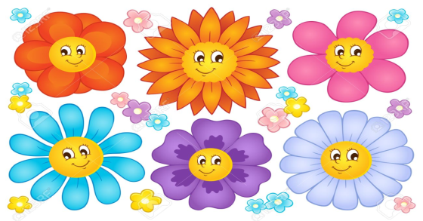

|  |  |
| --- | --- |
| ***A:*** | Where are you (0) now, Phong? |
| ***B:*** | I’m in the (1) _______. |
| ***A:*** | What are you doing? |
| ***B:*** | I’m playing (2) _______. What about you? What are you doing? |
| ***A:*** | I’m (3) _______ at home. |
| ***B:*** | What’s the weather (4) _______ in Ho Chi Minh City now? |
| ***A:*** | It’s very bad. It’s (5) _______. |

**Task 6. Make the questions.**

1. ____________________________________________________?

- Nam is in the garden.

2. ____________________________________________________?

– There are four cats.

3. ____________________________________________________?

– Quan has many birds.

4. ____________________________________________________?

– It is rainy today.

5. ____________________________________________________?

– Linda is flying kites in the park.

6. ____________________________________________________?

– I play badminton at break time.

**Task 7. Read , complete and write ‘Yes’ or ‘ No’**

Today is Saturday. The Description: C:\Documents and Settings\Abue\Escritorio\sunny.jpegDescription: http://www.fotosearch.com/bthumb/UNC/UNC265/u13440655.jpg………………..…... is very nice. It is not Description: http://www.fotosearch.com/bthumb/UNC/UNC265/u19767898.jpg…………………………rainy. It is sunny. I am in the 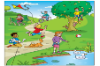…..…………

………………now. I’m playing badminton with Quan, Hung, Hai, and Tony. Alex and Hoa are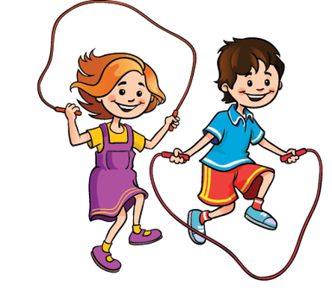…………… . Mai and Toby are 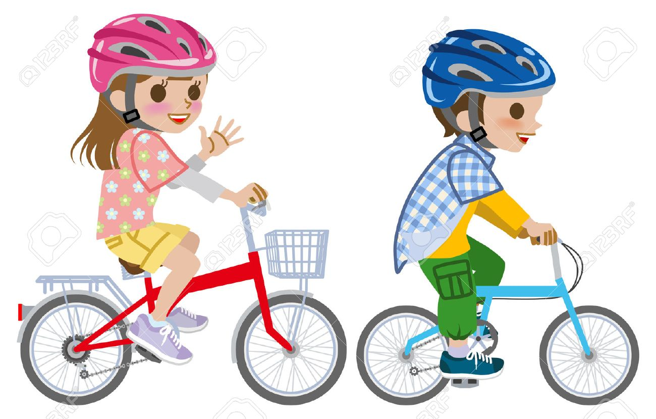………………. We are happy.

|  |  |
| --- | --- |
| 6.The children are in the park. |  |
| 7.The weather is rainy. |  |
| 8.Quan, Hung and Hai are playing badminton. |  |
| 9.Alex is playing badminton. |  |
| 10.Mai and Toby are cycling. |  |

**Task 8. Complete the paragraph with the following words.**



**Cycling**

**Garden**

**Flying**

**Reading**

**Five**

**Young**



**Bedroom**

**Sunny**

**Livingroom**

**Cooking**

**Goldfish**

My family has (1)…………….people: my grandmother, my parents, my brother and me. It is warm and (2)………………today. My grandmother is in the (3) ………………. . She is sleeping. She is seventy-nine years old and she is old. My father is (4) ……………….in the (5)………………..… . He is a teacher. He is forty-two years old, but he is (6)…………… . My mother is (7) ……………….in the kitchen. She is forty years old but she is beautiful. My brother is (8) ……………………….in the park. He is fifteen years old. He likes pets. He has a (9)………………. . And I am nine years old. I am (10)……………kites in the park with my dog.

**Task 9. Put the words in the correct order to make sentences.**

1 - playing / He / is / chess / his / with / friends.

……………….……………….……………….……………….

2 - her / She/ is / in/ bedroom / reading/ books/ .

……………….……………….……………….……………….

3 - Lan / and / Hoa / doing/ ? What / are /

- / are/ reading / They / bedroom/ . book / in / the /

……………….……………….……………….……………….

……………….……………….……………….………………

4 - playing/ volleyball / They / are / in / the

……………….……………….……………….……………….

5 - is sunny / The / and/ windy/ in / Quy Nhon/ today/ . weather /

……………….……………….……………….……………….

6 - weather / your / What/ is / in / city/ ?/ the/ like /

- is / windy / cloudy/ .It / and/

……………….……………….……………….………………

……………….……………….……………….………………

**ĐÁP ÁN**

**UNIT 19**

**Task 1.**

1 - c; 2 - c; 3 - b; 4 - a; 5 - d; 6 - a; 7 - d; 8 - d;

**Task 2.**

**1.b 2. 3.h 4.g 5.f 6.a 7.c 8.j 9.e 10.i**

**Task 3.**

 1. cycling 2. skating 3. skipping 4. singing 5. swimming

**Task 4.**

1. Description: https://s.sachmem.vn/public/sm-quizz/icons/checkbox-cross.png 2. Description: https://s.sachmem.vn/public/sm-quizz/icons/checkbox-tick.png 3. Description: https://s.sachmem.vn/public/sm-quizz/icons/checkbox-cross.png 4. Description: https://s.sachmem.vn/public/sm-quizz/icons/checkbox-tick.png 5. Description: https://s.sachmem.vn/public/sm-quizz/icons/checkbox-tick.png

**Task 5.**

 1. park 2. football 3. reading 4. like 5. rainy

**Task 6.**

1 - Where is Nam?

2 - How many cats are there?

3 - How many birds does Quan have?/

4 - What is the weather today like?

5 - What is Linda doing in the park?

6 - What do you do at break time?

**Task 7.**

1.weather 2.rainy 3.park 4.skipping 5.cycling

**6.yes 7.no 8.yes 9.no 10.yes**

**Task 8.**

My family has (1)……five……….people: my grandmother, my parents, my brother and me. It is warm and (2)………sunny………today. My grandmother is in the (3) …………bedroom……. . She is sleeping. She is seventy-nine years old and she is old. My father is (4) …reading……… .in the (5)…………living room……..… . He is a teacher. He is forty-two years old, but he is (6)……young……… . My mother is (7) ………cooking……….in the kitchen. She is forty years old but she is beautiful. My brother is (8) ……………cycling………….in the park. He is fifteen years old. He likes pets. He has a (9)………goldfish………. . And I am nine years old. I am (10)………flying……kites in the park with my dog.

**Task 9.**

1 - He is playing chess with his friends.

2 - She is reading books in her bedroom.

3 - What are Lan and Hoa doing? - They are reading book in the bedroom.

4 - They are playing volleyball in the schoolyard.

5 - The weather is sunny and windy in Quy Nhon today.

6 - What is the weather like in your city? - It is windy and cloudy.